|  |  |
| --- | --- |
| Student Number | T0269675 |
| Student Name | Prang Kongthongluck |
| Module Name | Software Design and Implementation |
| Module Code | IY453(Yellow) |

Contents

Introduction 3

Specification of the Program 3

Analysis 4

Design 5

Design l 5

Design II 9

Evaluation 10

Testing 11

Test Table 11

Screen Shot 18

Source Code 26

Header.h 26

MyForm.h 31

Reference 52

# Introduction

The purpose of the assignment is to create a quiz game program, that allows users to answer the question with a different interaction. The project will contain two different sections, programing part and the report part.

This report will illustrate the analysis of the project, design of the software, testing, evaluation, and source code. Analysis part will demonstrate planning of the assignment and breakdown on the necessary element on the software. Design part reflects the layout of the user interface and essential software element that will be used on the program. This part also consists of the flow diagram that will describe how the program work, data flow. Testing is composed of the testing table, where function of the program will be testes with different input data and the screenshot of the running software. Evaluation part will give the information about the strength and weakness of the software and what could be improved. Finally, the report will end with source code section and reference to source knowledge.

## Specification of the Program

The program is required to create a Geography topic quiz game. The user can interact with the program in different activities, for example, clicking or drag and drop. The program will also be able, to sum up, the score of the user’s performance. The software provides feedback, the correct answer to the user. This program will consist of the use of a class and inheritance.

# Analysis

The task of the assignment is to design a window-based quiz program. I plan the schedule into four different sections, research, design, build and develop.

The research part is the most important. I will research for the topic of the quiz, what question should I ask on the quiz and pick three different input interaction to be on my program. On the first few weeks of the project, I will study about c++ language, object-oriented programming and how to build a user interface using c++ language. This section is to prepare myself before starting to program the project. I will have to collect and gain essential skill like understanding of c++ syntax and how to use object-oriented. I will practice using visual studio c++/CLR to try to build the interface.  
  
Secondly is the design part. In this section, I will sketch the layout of the interface window and roughly make a flow charts to see how the program should function.  
  
After the design, I will start programming and try to make it as close to the design as possible. Then start the testing and find a room to improve the program.

# Design

## Design l

Opening page of the program

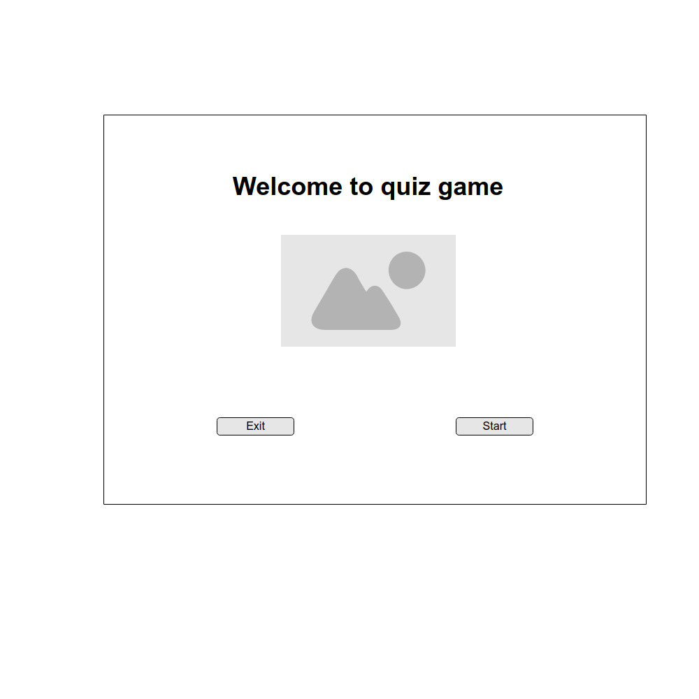

Multiple question layout. When the user clicks on check button, the next button will pop up with the correct/wrong message, correct answer and user score and check button will be gone. Next button will not be visible on the screen if the answer of the question is not submitted. User will have to answer every question to complete the quiz. At the same time when next button is visible check button will not show up to prevent user to double submit the answer and make score inaccurate.

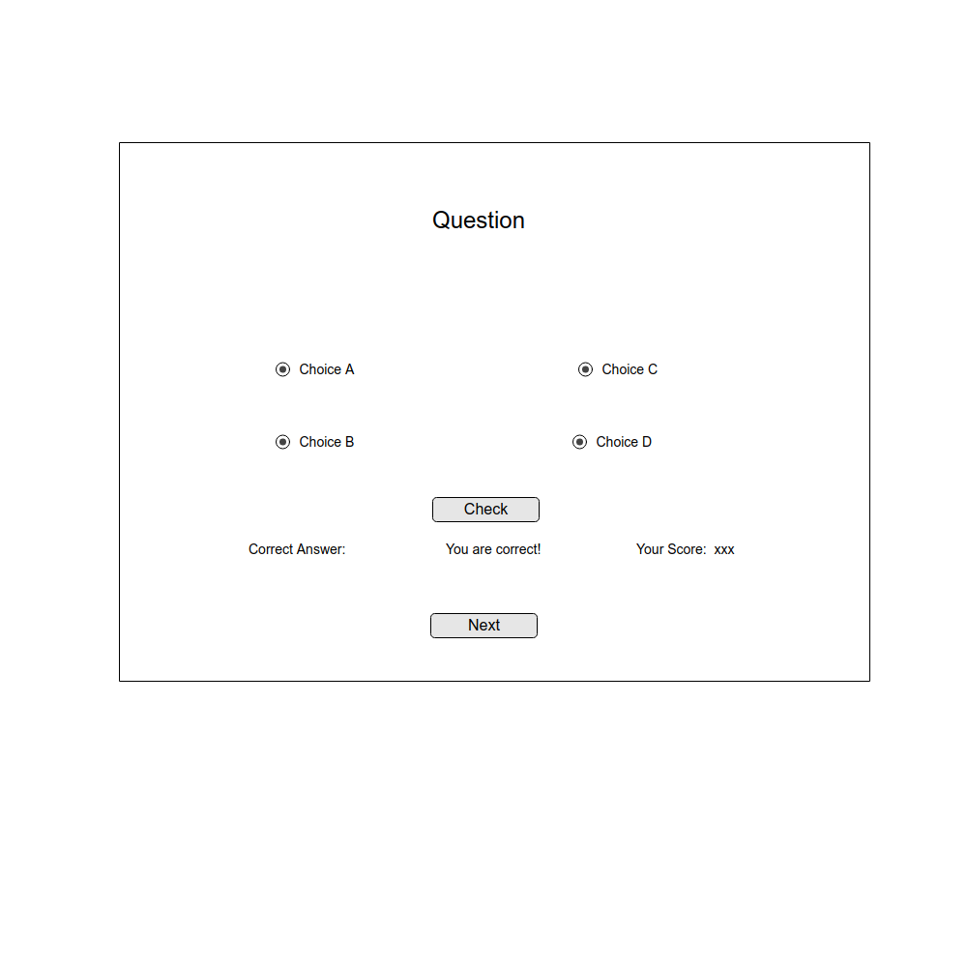

True/ False question interface layout. User will choose correct answer(true/false) from the combo box and click check to add up score is the answer is correct.

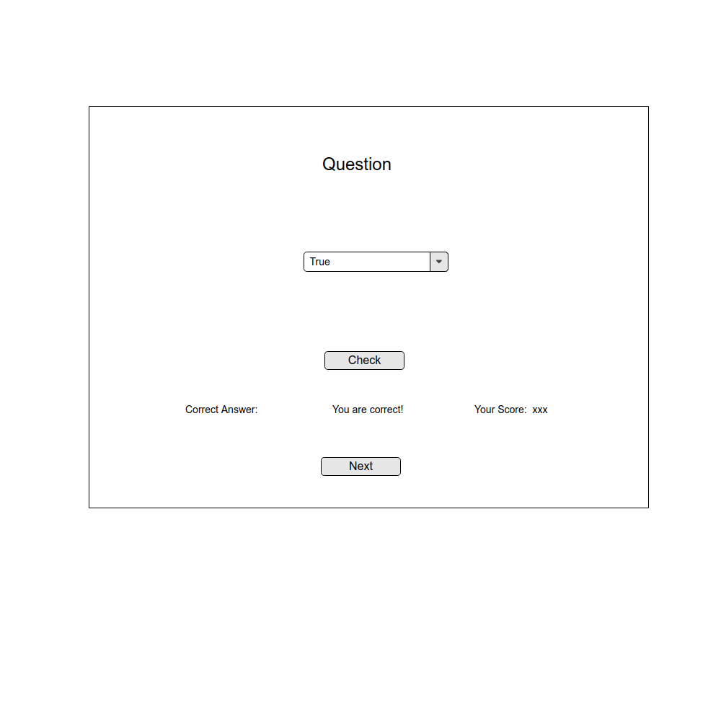

Drag and drop question layout. User will drag the correct answer into the black box and click check to add uo score and check for the correct answer

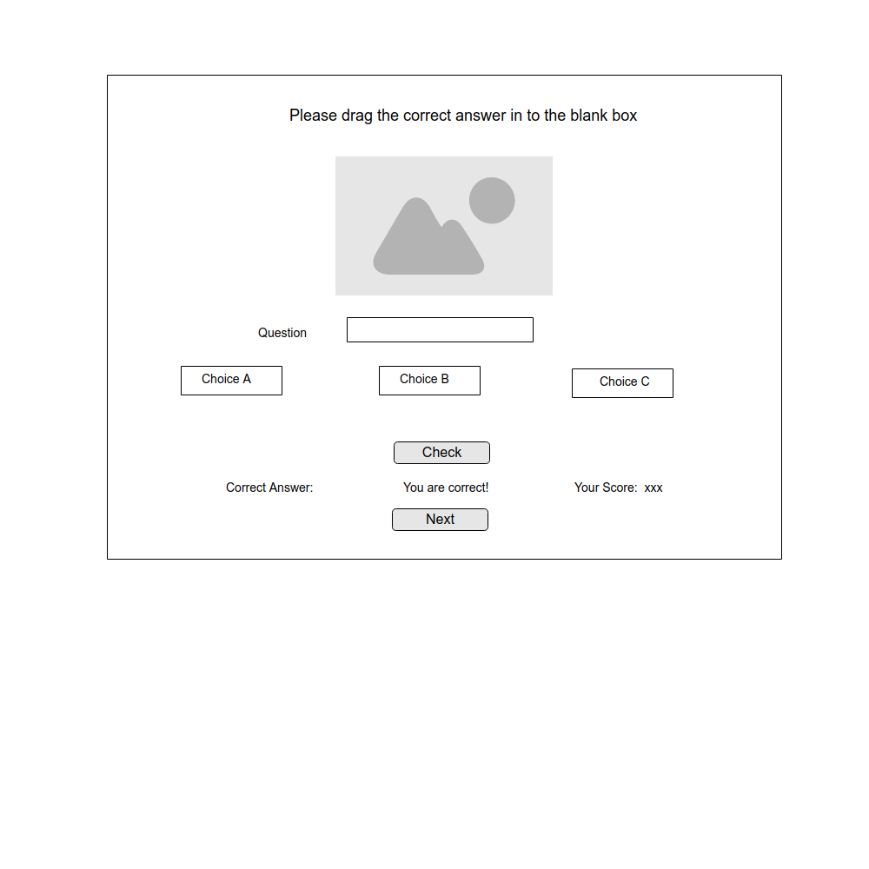

After complete all the question, this pag will show the overall score of the user.

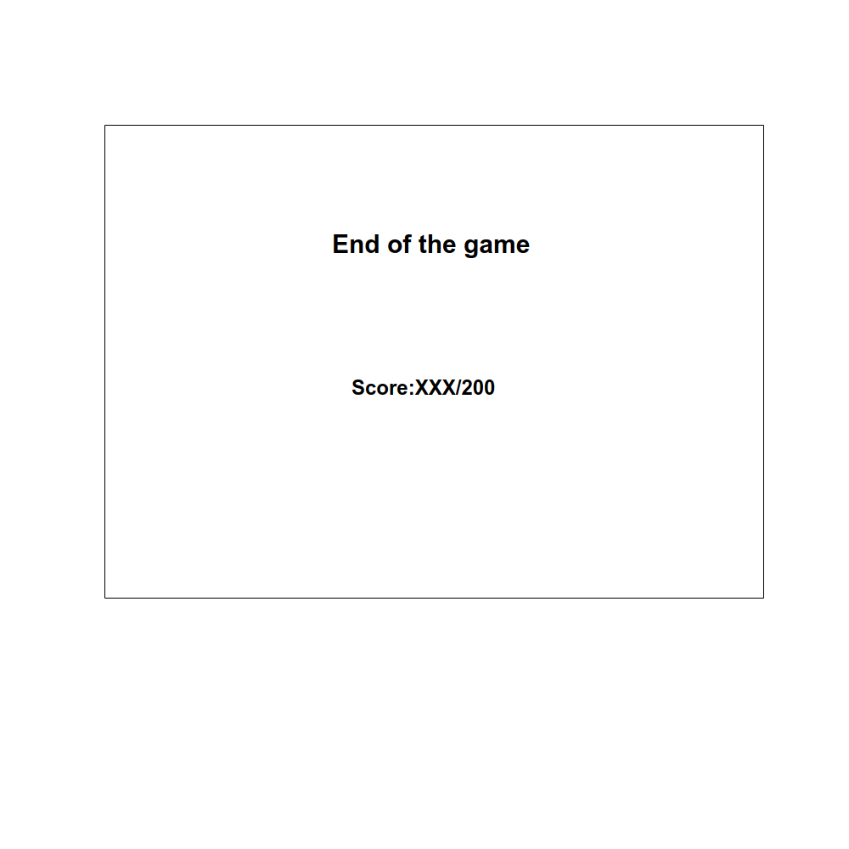

On the header.h file object-oriented classes are created to set data that will be display on the interface. One protocol class is created to set up essential data like question text, a score of each question and correct answer. Another class is then created to set extra data like choices. This class will be inherited from the protocol class. Data from classes then pass to the interface. A class object is changed into another class object every time user clicks on next button by using switch and case statement

## Design II

Flow chart

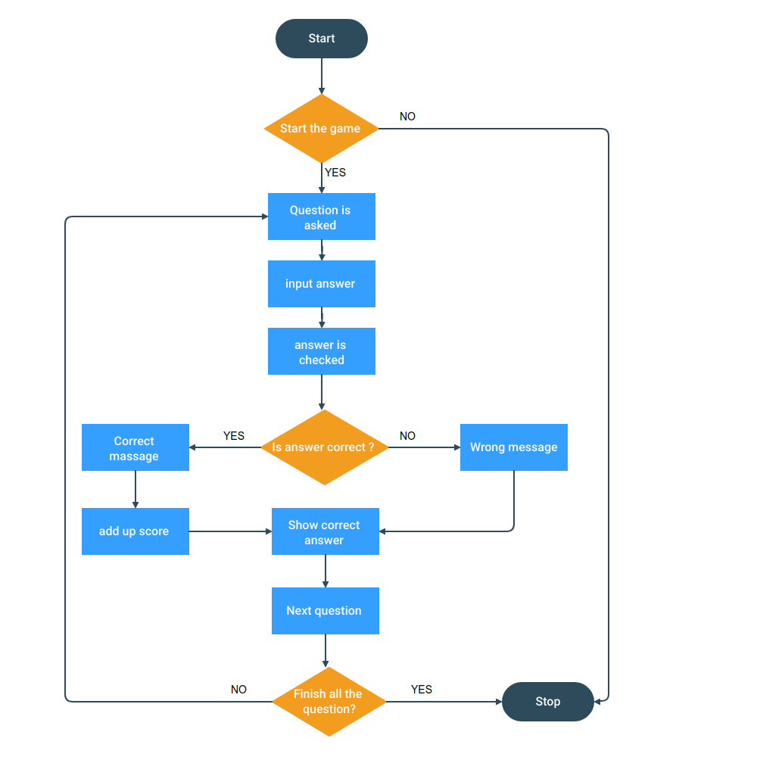

# Evaluation

The purpose of this project is to create a quiz program that has a variety of user interaction. There is 3 different type of question on the program, multiple-choice question, true or false question and drag and drop the question.

Strength of this program is validation. On this program, user will not pass in answer my typing action. This action can bring up a lot of error as the user has freedom to input any type of text data to the answer. The program limits input value from the user by letting the user answer question my click action and drag and drop action only. This method will ensure that the input data type of answer will be correct and do not crash the program. This program also shows the correct answer of each question right after the user click check to submit an answer for checking. Performance score of player will be shown throughout the game.

However, the program is not the best user friendly and not very flexible. This program does not provide a button like a back button for user to go back to the previous question and re-enter an answer. It also does not have a play again button to fulfil user when he/she want to repeat the game.

The program still has a lot of room to improve. For example, enhance the appearance of the interface by adding more design or background. The quiz game can be more interesting with more variety of question type. A user can be more enjoyable if the game has a back button for the user to fix his/her response or questions could be arranged in a random sequence

# Testing

## Test Table

|  |  |  |  |  |  |  |
| --- | --- | --- | --- | --- | --- | --- |
| Test No. | Item to test | Test description | Test action | Expected result | Actual result | Comment |
| 1 | private: System::Void radioButton1_CheckedChanged_1 | Valid event | Click Button | Answer=A | Program set user answer as “A” | - |
| 2 | private: System::Void radioButton1_CheckedChanged_1 | Valid function | Void radioButton1_CheckedChanged_1 | Answer=A | Program set user answer as “A” | - |
| 3 | private: System::Void radioButton1_CheckedChanged_1 | Function is renamed | Void rename (): | Answer=A | Program crashed-command function does not define | Double check spelling |
| 4 | private: System::Void radioButton1_CheckedChanged_1 | Invalid event | Drag the item | Answer=A | Item can’t be dragged - no input to answer | Backup function for different event |
| 5 | private: System::Void radioButton2_CheckedChanged_1 | Valid event | Click Button | Answer=B | Program set user answer as “B” | - |
| 6 | private: System::Void radioButton2_CheckedChanged_1 | Valid function | Void radioButton2_CheckedChanged_1() | Answer=B | Program set user answer as “B” | - |
| 7 | private: System::Void radioButton2_CheckedChanged_1 | Function is renamed | Void rename (): | Answer=B | Program crashed-command function does not define | Double check spelling |
| 8 | private: System::Void radioButton2_CheckedChanged_1 | Invalid event | Drag the item | Answer=B | Item cannot be dragged - no input to answer | Backup function for different event |
| 9 | private: System::Void radioButton3_CheckedChanged | Valid event | Click Button | Answer=C | Program set user answer as “C” | - |
| 10 | private: System::Void radioButton3_CheckedChanged | Valid function | Void radioButton3_CheckedChanged_1() | Answer=C | Program set user answer as “C” | - |
| 11 | private: System::Void radioButton3_CheckedChanged | Function is renamed | Void rename (): | Answer=C | Program crashed-command function does not define | Double check spelling |
| 12 | private: System::Void radioButton3_CheckedChanged | Invalid event | Drag the item | Answer=C | Item cannot be dragged - no input to answer | Backup function for different event |
| 13 | private: System::Void radioButton4_CheckedChanged_1 | Valid event | Click Button | Answer=D | Program set user answer as “D” | - |
| 14 | private: System::Void radioButton4_CheckedChanged_1 | Valid function | Void radioButton4_CheckedChanged_1() | Answer=D | Program set user answer as “D” | - |
| 15 | private: System::Void radioButton4_CheckedChanged_1 | Function is renamed | Void rename (): | Answer=D | Program crashed-command function does not define | Double check spelling |
| 16 | private: System::Void radioButton4_CheckedChanged_1 | Invalid event | Drag the item | Answer=D | Item cannot be dragged - no input to answer | Backup function for different event |
| 17 | public: System::Void button1_Click | Valid event | Click Button | Check answer, add up score | Program check the answer and pop up correct/wrong messages ,  Current score and correct answer | - |
| 18 | public: System::Void button1_Click | Valid function | Void button1_Click() | Check answer, add up score | Program check the answer and pop up correct/wrong messages ,  Current score and correct answer | - |
| 19 | public: System::Void button1_Click | Function is renamed | Void rename (): | Check answer, add up score | Program crashed-command function does not define | Double check spelling |
| 20 | public: System::Void button1_Click | Invalid event | Drag the item | Check answer, add up score | Item cannot be dragged - check answer process does not occur | Backup function for different event |
| 21 | private: System::Void button2_Click | Valid event | Click Button | Next question show up | New question and choice show up | - |
| 22 | private: System::Void button2_Click | Valid function | Void button2_Click() | Next question show up | New question and choice show up | - |
| 23 | private: System::Void button2_Click | Function is renamed | Void rename (): | Next question show up | Program crashed-command function does not define | Double check spelling |
| 24 | private: System::Void button2_Click | Invalid event | Drag the item | Next question show up | Item cannot be dragged – new question doesn’t show up | Backup function for different event |
| 25 | private: System::Void button3_Click | Valid event | Click Button | True / false question section pop up | True/false question and answer combo box show up | - |
| 26 | private: System::Void button3_Click | Valid function | Void button3_Click() | True / false question section pop up | True/false question and answer combo box show up | - |
| 27 | private: System::Void button3_Click | Function is renamed | Void rename (): | True / false question section pop up | Program crashed-command function does not define | Double check spelling |
| 28 | private: System::Void button3_Click | Invalid event | Drag the item | True / false question section pop up | Item cannot be dragged – true/false question doesn’t show up | Backup function for different event |
| 29 | comboBox1 | Valid event | Select item by clicking | Answer=selected choice | Selected choice is inputted to answer | - |
| 30 | comboBox1 | Valid function | String^ gettext = comboBox1->Text->ToString(); | Answer=selected choice | Selected choice is inputted to answer | - |
| 31 | comboBox1 | Function is renamed | Void rename (): | Answer=selected choice | Program crashed-command function does not define | Double check spelling |
| 32 | comboBox1 | Invalid event | Type in the box | Answer=selected choice | User cannot type in the box – data of selected cannot be edited | - |
| 33 | comboBox1 | Invalid event | Drag the item | Answer=selected choice | Item cannot be dragged - no input to answer | Backup function for different event |
| 34 | private: System::Void button4_Click | Valid event | Click Button | Check answer, add up score | Program check the answer and pop up correct/wrong messages ,  Current score and correct answer | - |
| 35 | private: System::Void button4_Click | Valid function | Void button4_Click() | Check answer, add up score | Program check the answer and pop up correct/wrong messages ,  Current score and correct answer | - |
| 36 | private: System::Void button4_Click | Function is renamed | Void rename (): | Check answer, add up score | Program crashed-command function does not define | Double check spelling |
| 37 | private: System::Void button4_Click | Invalid event | Drag the item | Check answer, add up score | Item cannot be dragged - check answer process does not occur | Backup function for different event |
| 38 | private: System::Void button5_Click | Valid event | Click Button | Next question show up | New question and choice show up | - |
| 39 | private: System::Void button5_Click | Valid function | Void button5_Click() | Next question show up | New question and choice show up | - |
| 40 | private: System::Void button5_Click | Function is renamed | Void rename (): | Next question show up | Program crashed-command function does not define | Double check spelling |
| 41 | private: System::Void button5_Click | Invalid event | Drag the item | Next question show up | Item cannot be dragged – new question doesn’t show up | Backup function for different event |
| 42 | private: System::Void button7_Click | Valid event | Click Button | Drag and drop question section pop up | Drag and drop question and answer choice boxes show up | - |
| 43 | private: System::Void button7_Click | Valid function | Void button3_Click() | Drag and drop question section pop up | Drag and drop question and answer choice boxes show up | - |
| 44 | private: System::Void button7_Click | Function is renamed | Void rename (): | Drag and drop question section pop up | Program crashed-command function does not define | Double check spelling |
| 45 | private: System::Void button7_Click | Invalid event | Drag the item | Drag and drop question section pop up | Item cannot be dragged – Drag and drop question doesn’t show up | Backup function for different event |
| 46 | private: System::Void textBox1_MouseDown | Valid event | Drag item | Data in box is select and able to be dragged | User can drag data in box around the window | - |
| 47 | private: System::Void textBox1_MouseDown | Valid function | Void textBox1_MouseDown() | Data in box is select and able to be dragged | User can drag data in box around the window |  |
| 48 | private: System::Void textBox1_MouseDown | Function is renamed | Void rename (): | Data in box is select and able to be dragged | Program crashed-command function does not define | Double check spelling |
| 49 | private: System::Void textBox1_MouseDown | Invalid event | Type in the box | Value in box does not change | User can type in the box bit the text in the box will change back to the default value | - |
| 50 | private: System::Void textBox6_DragEnter | Valid event | Drag item | Copy value from the dragged item into answer box | Text value from dragged box(choice) is copied to the answer box | - |
| 51 | private: System::Void textBox6_DragEnter | Valid function | Void textBox6_DragEnter() | Copy value from the dragged item into answer box | Text value from dragged box(choice) is copied to the answer box | - |
| 52 | private: System::Void textBox6_DragEnter | Function is renamed | Void rename (): | Copy value from the dragged item into answer box | Program crashed-command function does not define | Double check spelling |
| 53 | private: System::Void textBox6_DragEnter | Invalid event | Type in the box | Copy value from the dragged item into answer box | User can edit copied text in the answer box | Limit function of BOX- not to be typed in |
| 54 | private: System::Void textBox6_DragDrop | Valid event | Drop item in answer box | Answer = data in dragged box | Data in the dragged box is inputted to answer | - |
| 55 | private: System::Void textBox6_DragDrop | Valid function | Void textBox6_DropEnter() | Answer = data in dragged box | Data in the dragged box is inputted to answer | - |
| 56 | private: System::Void textBox6_DragDrop | Function is renamed | Void rename (): | Answer = data in dragged box | Program crashed-command function does not define | Double check spelling |
| 57 | private: System::Void textBox6_DragDrop | Invalid event | Type in the box | Answer = data in dragged box | Answer = data in answer box – data in the answer box can be edit or input by user | Limit function of BOX- not to be typed in |
| 58 | private: System::Void button6_Click | Valid event | Click Button | Check answer, add up score | Program check the answer and pop up correct/wrong messages ,  Current score and correct answer | - |
| 59 | private: System::Void button6_Click | Valid function | Void button6_Click() | Check answer, add up score | Program check the answer and pop up correct/wrong messages ,  Current score and correct answer | - |
| 60 | private: System::Void button6_Click | Function is renamed | Void rename (): | Check answer, add up score | Program crashed-command function does not define | Double check spelling |
| 61 | private: System::Void button6_Click | Invalid event | Drag the item | Check answer, add up score | Item cannot be dragged - check answer process does not occur | Backup function for different event |
| 62 | private: System::Void button8_Click | Valid event | Click Button | Next question show up | New question and choice show up | When next question show up data in answer box should be empty. |
| 63 | private: System::Void button8_Click | Valid function | Void button8_Click() | Next question show up | New question and choice show up | - |
| 64 | private: System::Void button8_Click | Function is renamed | Void rename (): | Next question show up | Program crashed-command function does not define | Double check spelling |
| 65 | private: System::Void button8_Click | Invalid event | Drag the item | Next question show up | Item cannot be dragged – new question doesn’t show up | Backup function for different event |
| 66 | private: System::Void button9_Click | Valid event | Click Button | Game start | First question pop up | - |
| 67 | private: System::Void button9_Click | Valid function | Void button9_Click() | Game start | First question pop up | - |
| 68 | private: System::Void button9_Click | Function is renamed | Void rename (): | Game start | Program crashed-command function does not define | Double check spelling |
| 69 | private: System::Void button9_Click | Invalid event | Drag the item | Game start | Item cannot be dragged – first question doesn’t show up | Backup function for different event |
| 70 | private: System::Void button10_Click | Valid event | Click Button | Exit game | Exit game – window close down | - |
| 71 | private: System::Void button10_Click | Valid function | Void button10_Click() | Exit game | Exit game – window close down | - |
| 72 | private: System::Void button10_Click | Function is renamed | Void rename (): | Exit game | Program crashed-command function does not define | Double check spelling |
| 73 | private: System::Void button10_Click | Invalid event | Drag the item | Exit game | Item cannot be dragged – window is not close down | Backup function for different event |
| 74 | private: System::Void button11_Click | Valid event | Click Button | Exit game | Exit game – window close down | - |
| 75 | private: System::Void button11_Click | Valid function | Void button11_Click() | Exit game | Exit game – window close down | - |
| 76 | private: System::Void button11_Click | Function is renamed | Void rename (): | Exit game | Program crashed-command function does not define | Double check spelling |
| 77 | private: System::Void button11_Click | Invalid event | Drag the item | Exit game | Item cannot be dragged – window is not close down | Backup function for different event |

## Screen Shot

Opening window.

Click start button to start the game .

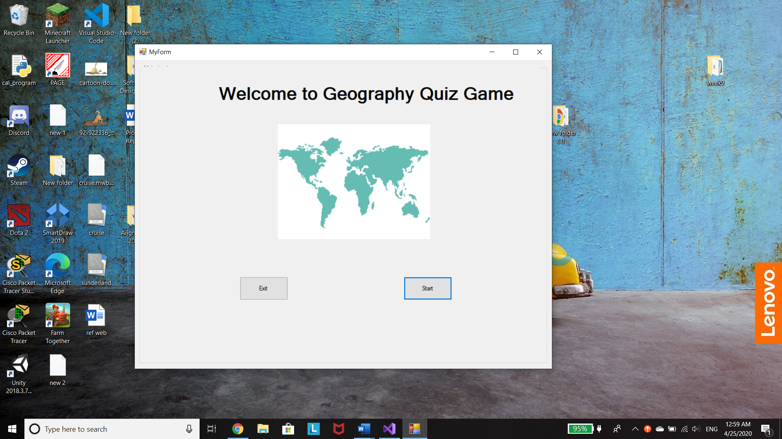

First multiple choice question pop up after click on start button.

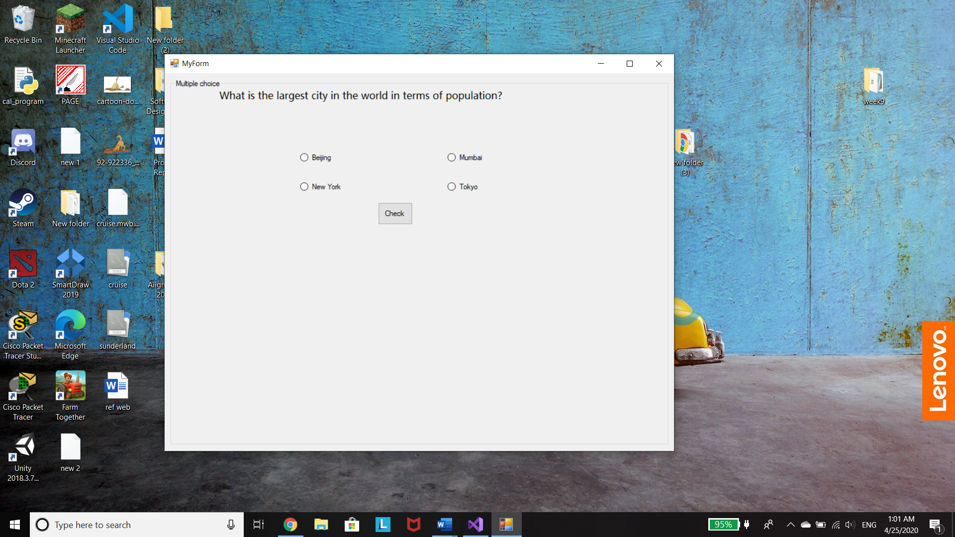

Choose answer by clicking at the radio button and click check to submit and sum up score. If the answer is correct score will add up, solution of the answer and correct answer message will show.

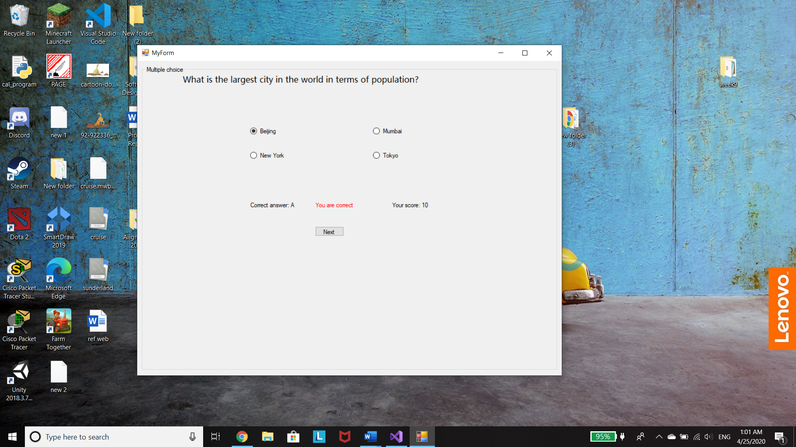

After click next button next questiom and new choice will show up.

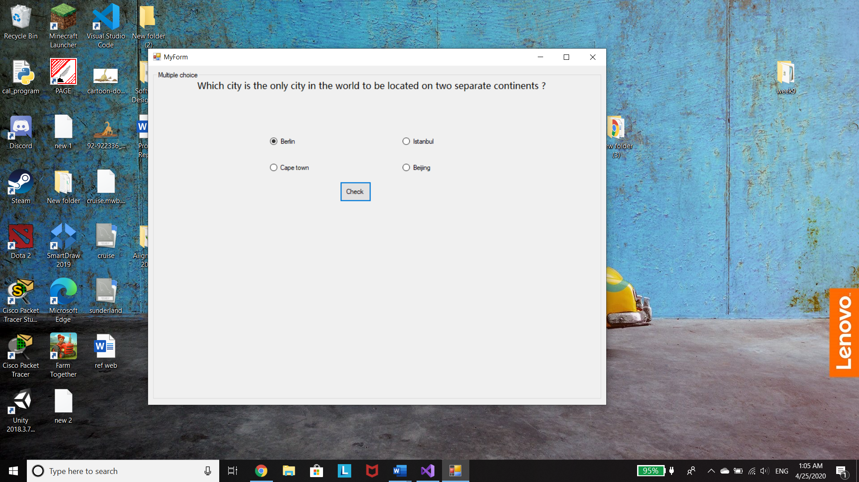

If the answer is wrong ,score will remain the same, wrong answer message and soluation will show up.

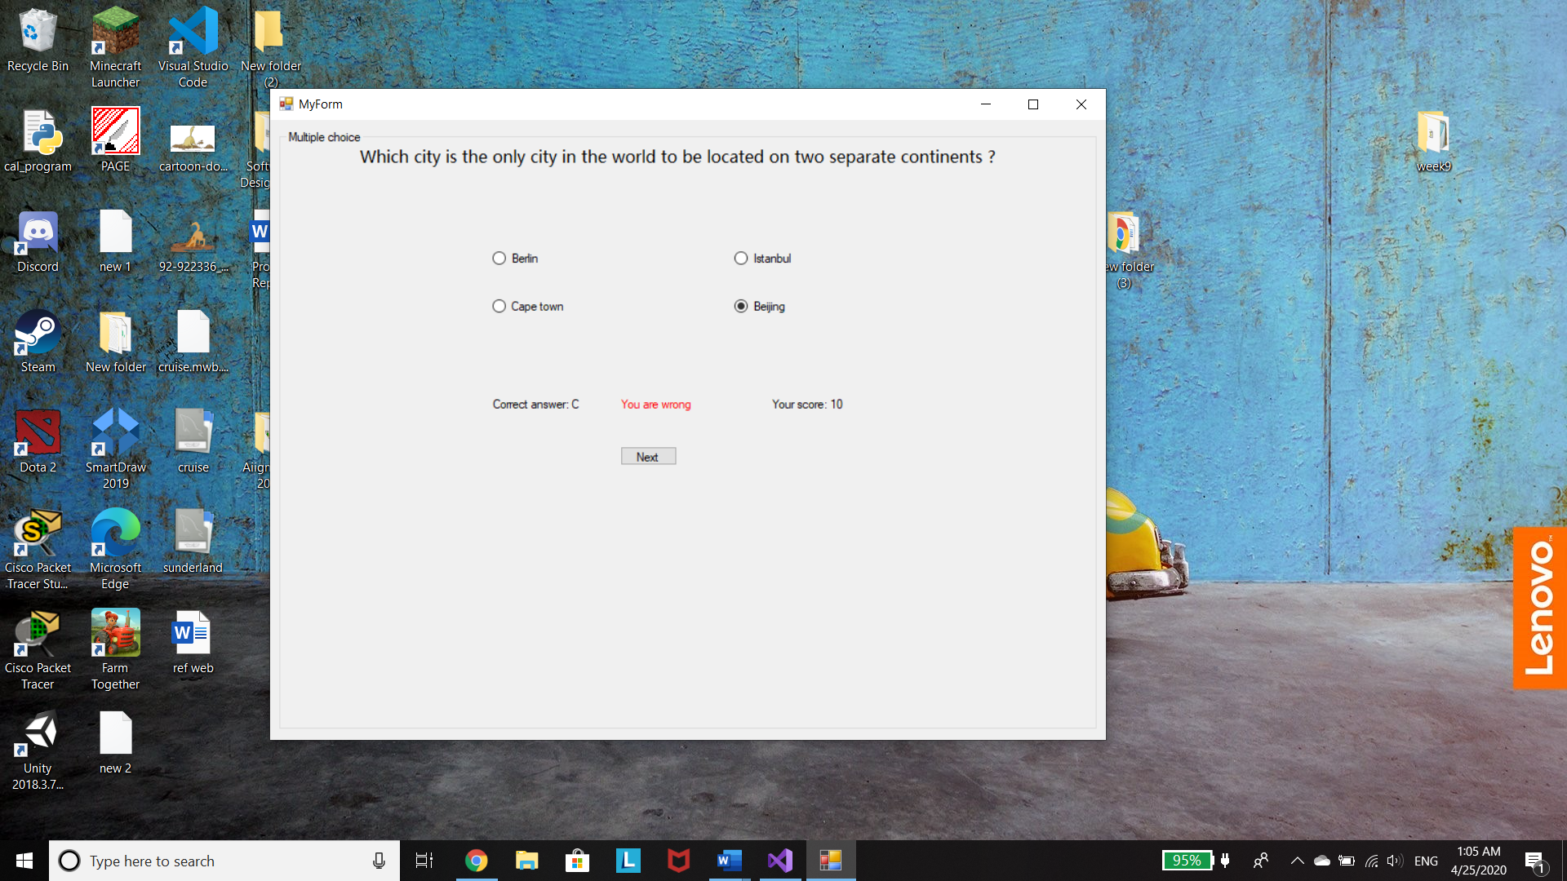

After completed the multiple choice section, this window will show up and to conttinue the game user have to click on contuniu button.

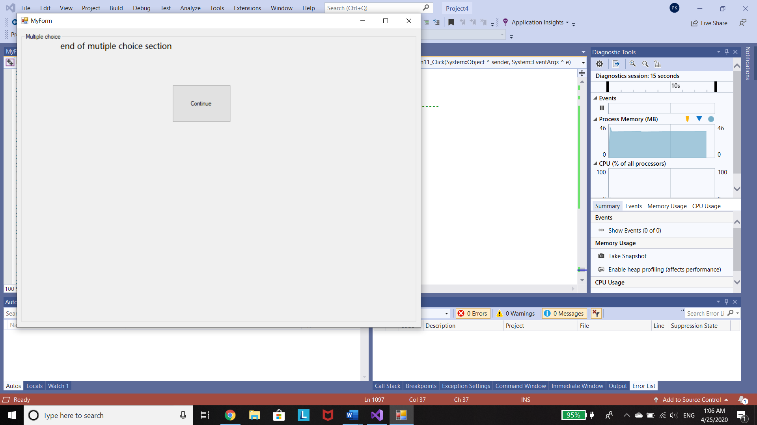

True/ False question section. User will input answer by select the correc answer from comboBox.

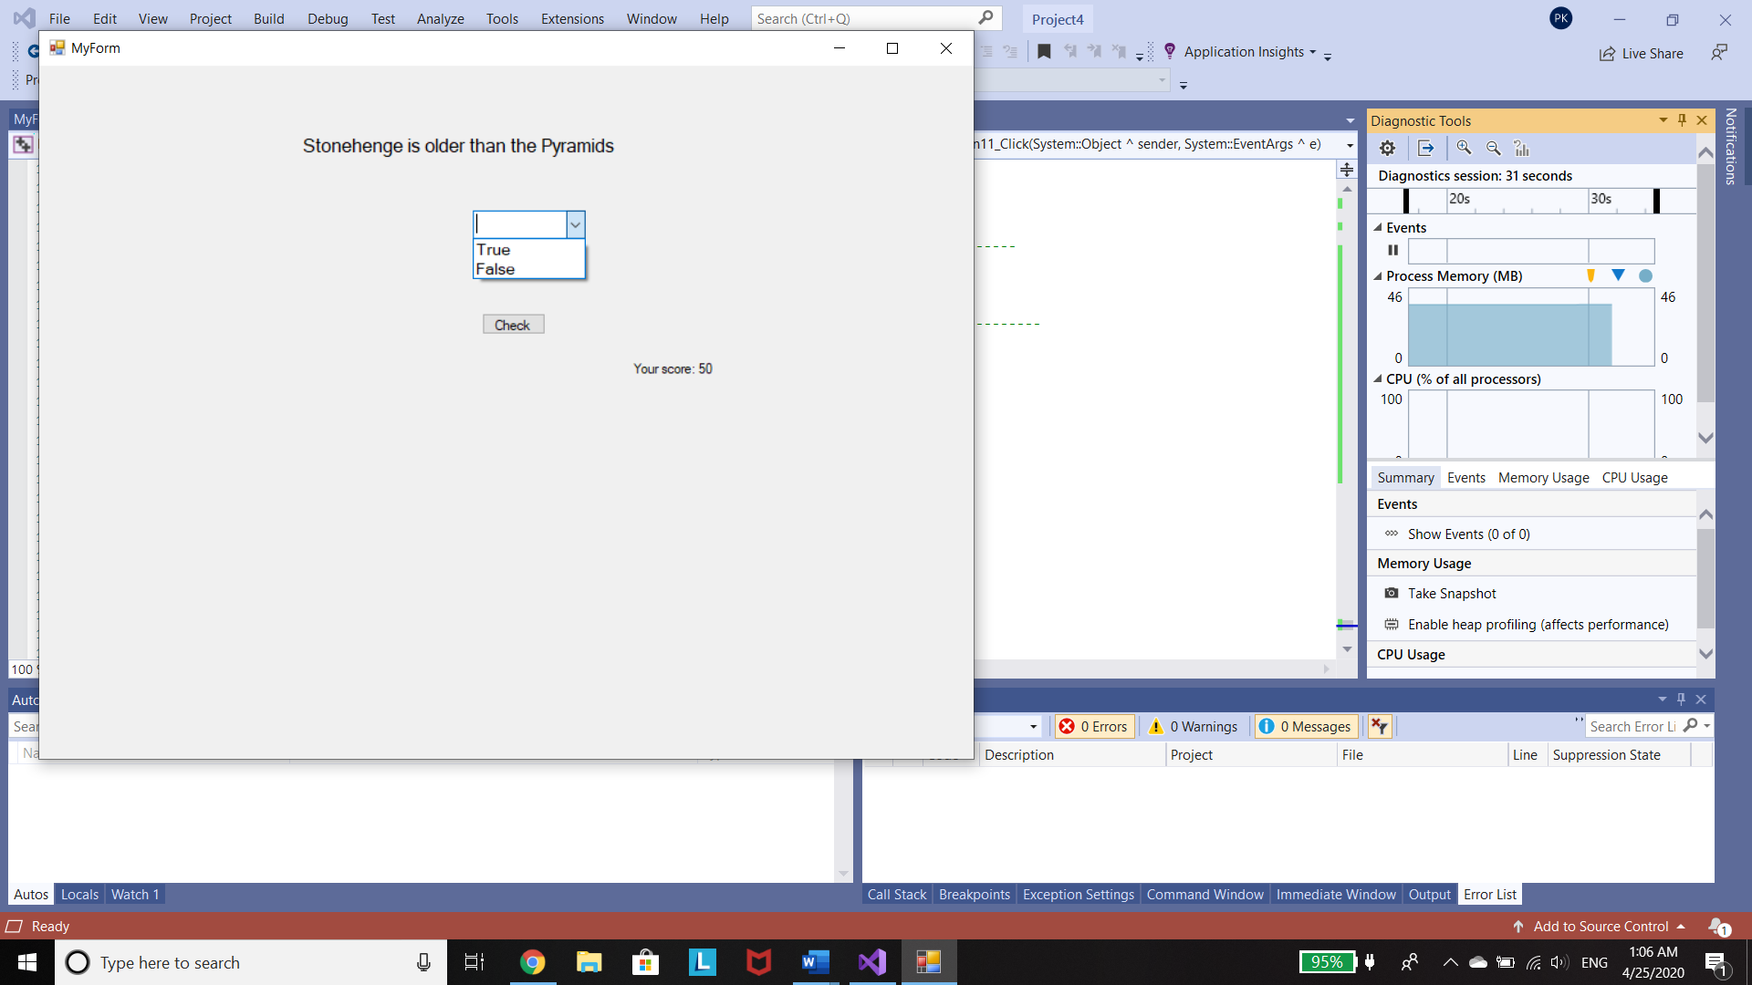

Score add up when answer is correct.

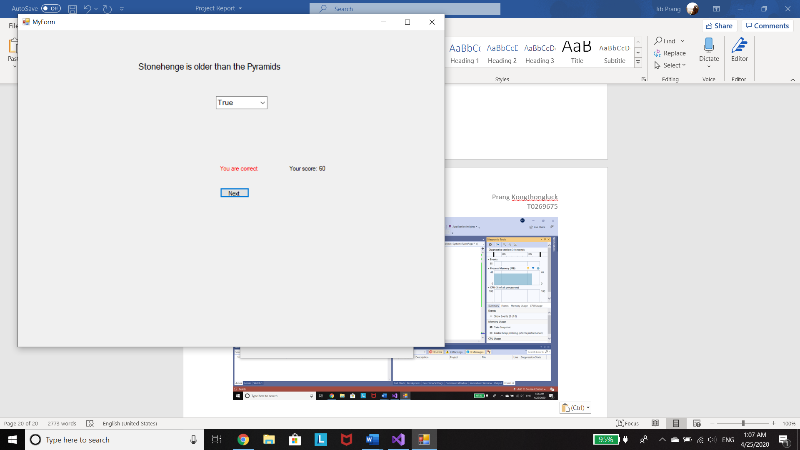

Next question shows when click on next button

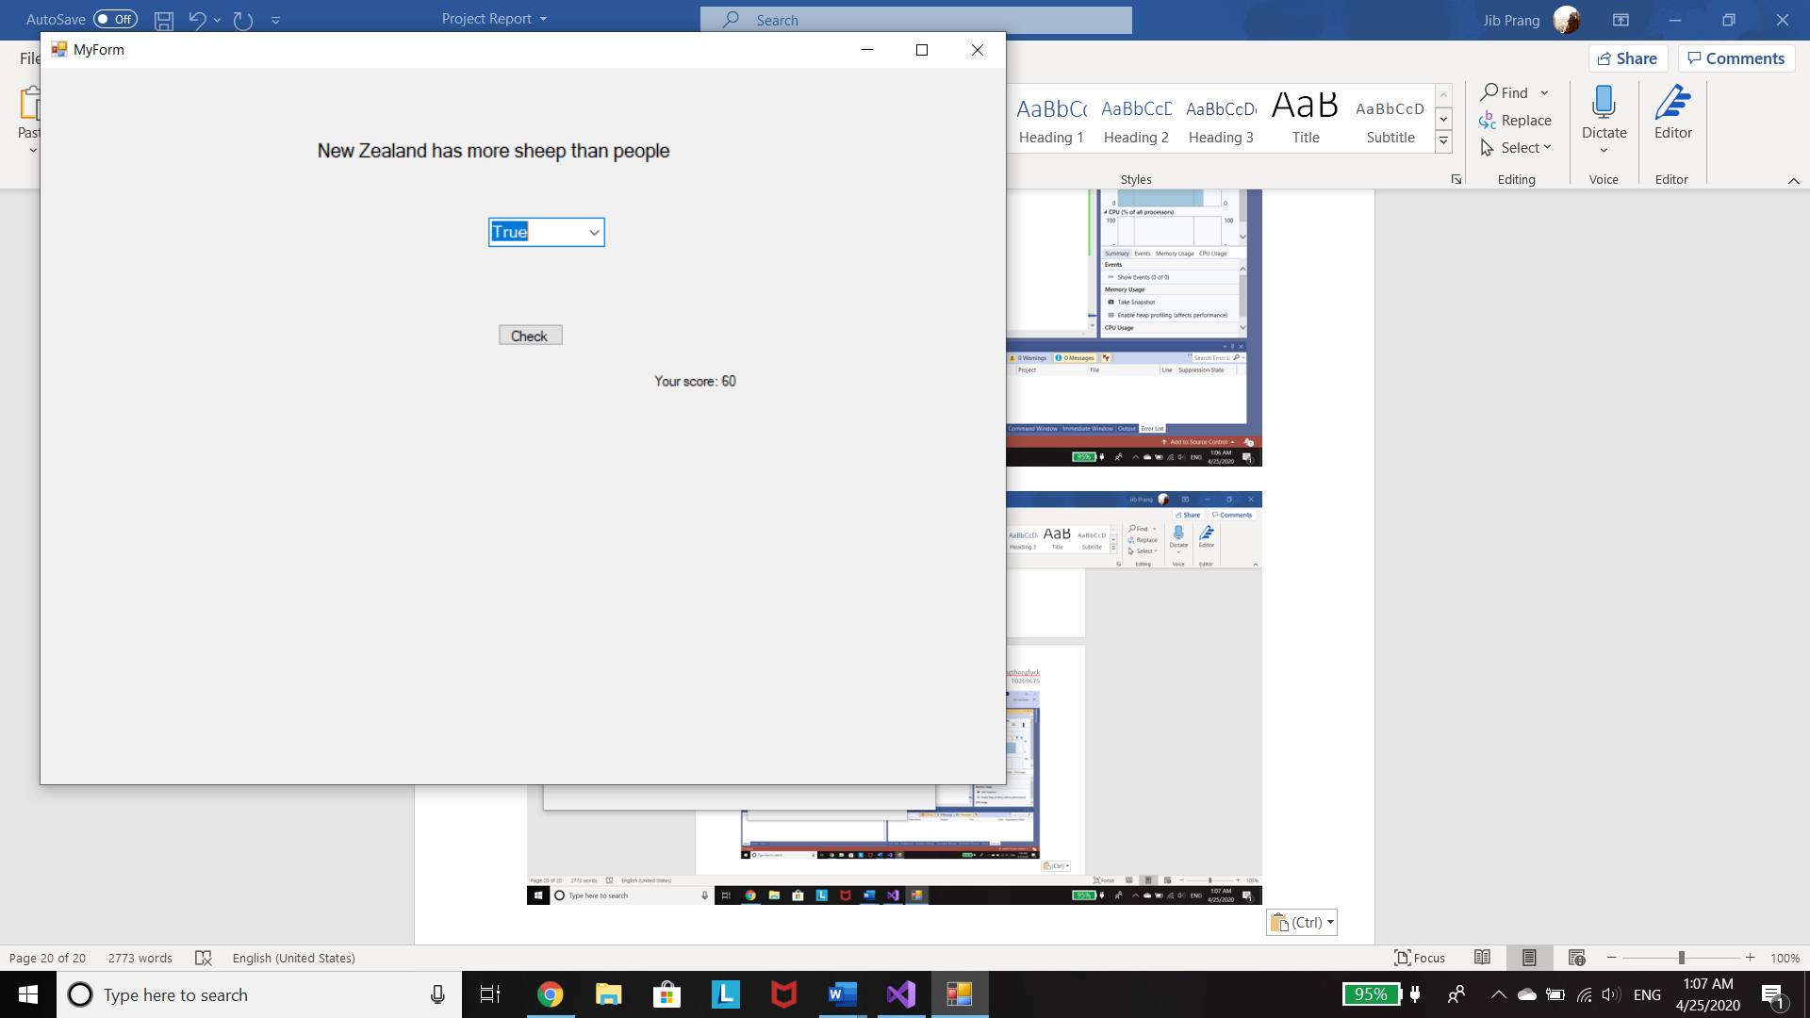

Wrong answer. Score remain same.

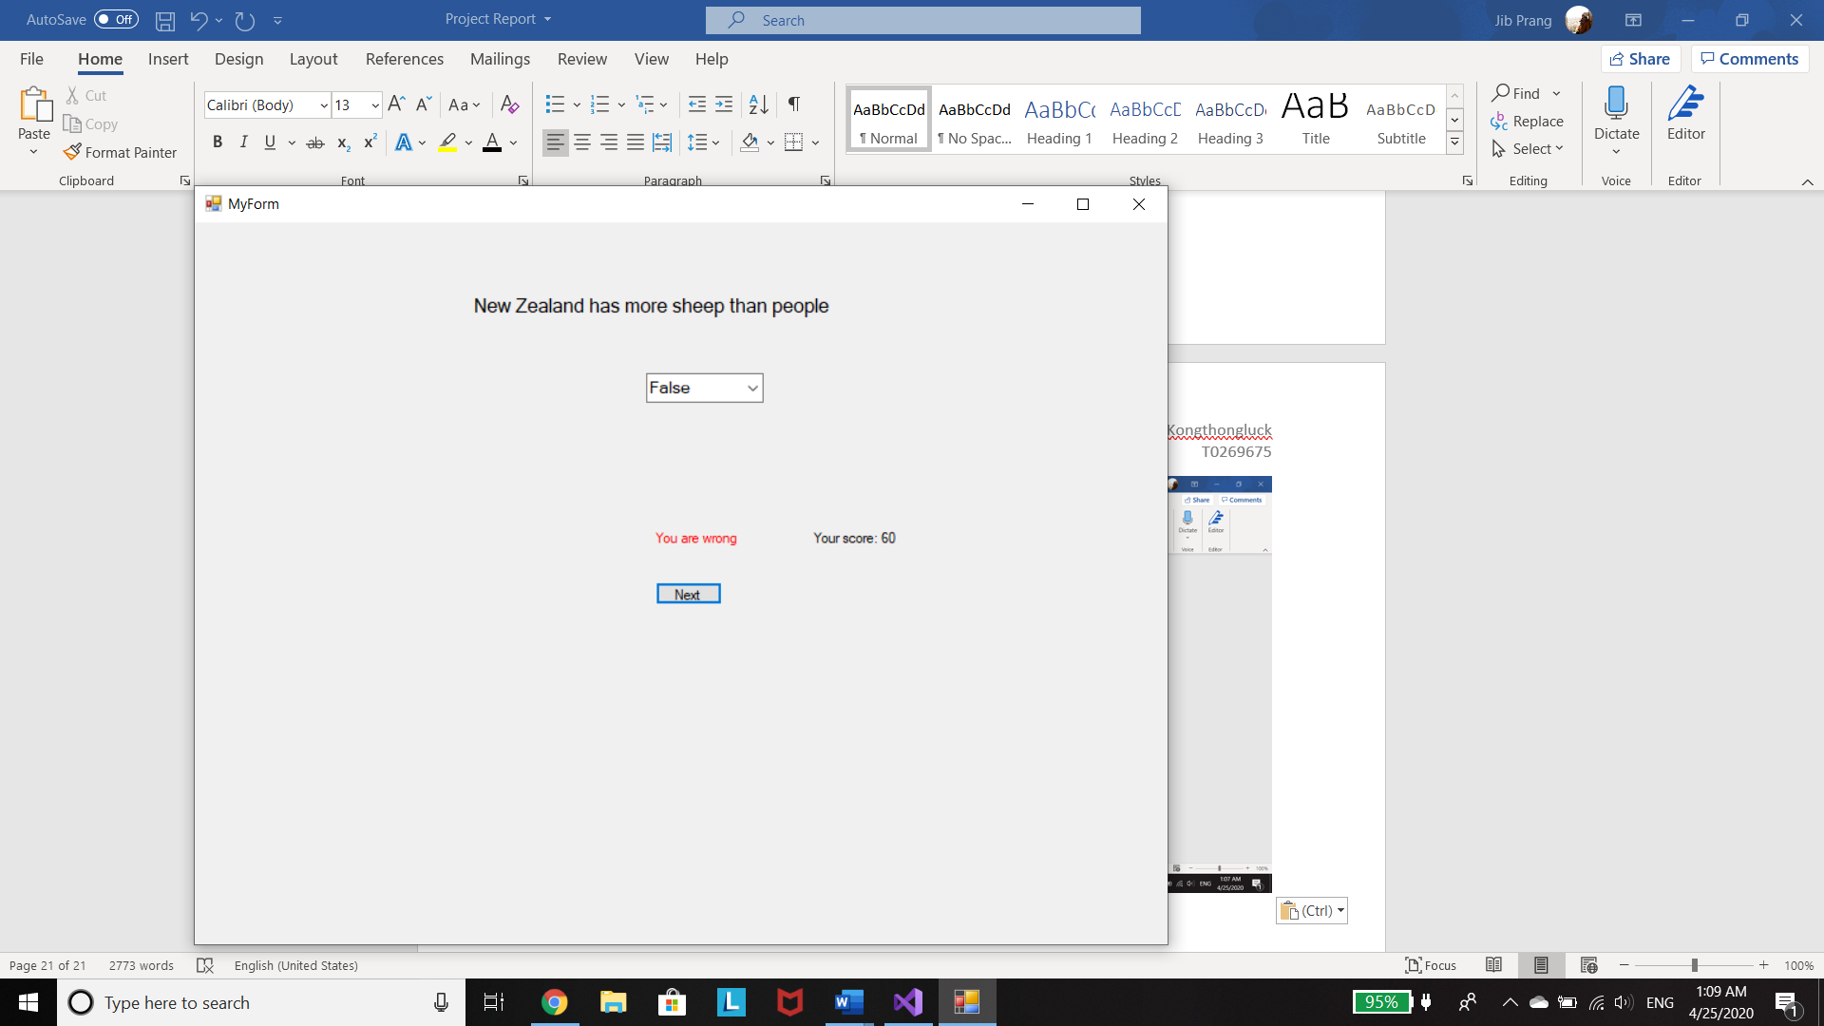

End of true and flase section. Click continue to start drag and drop question.

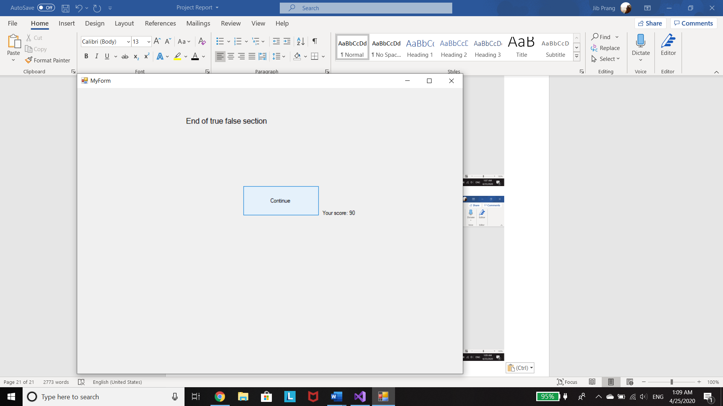

Start drag and drop section

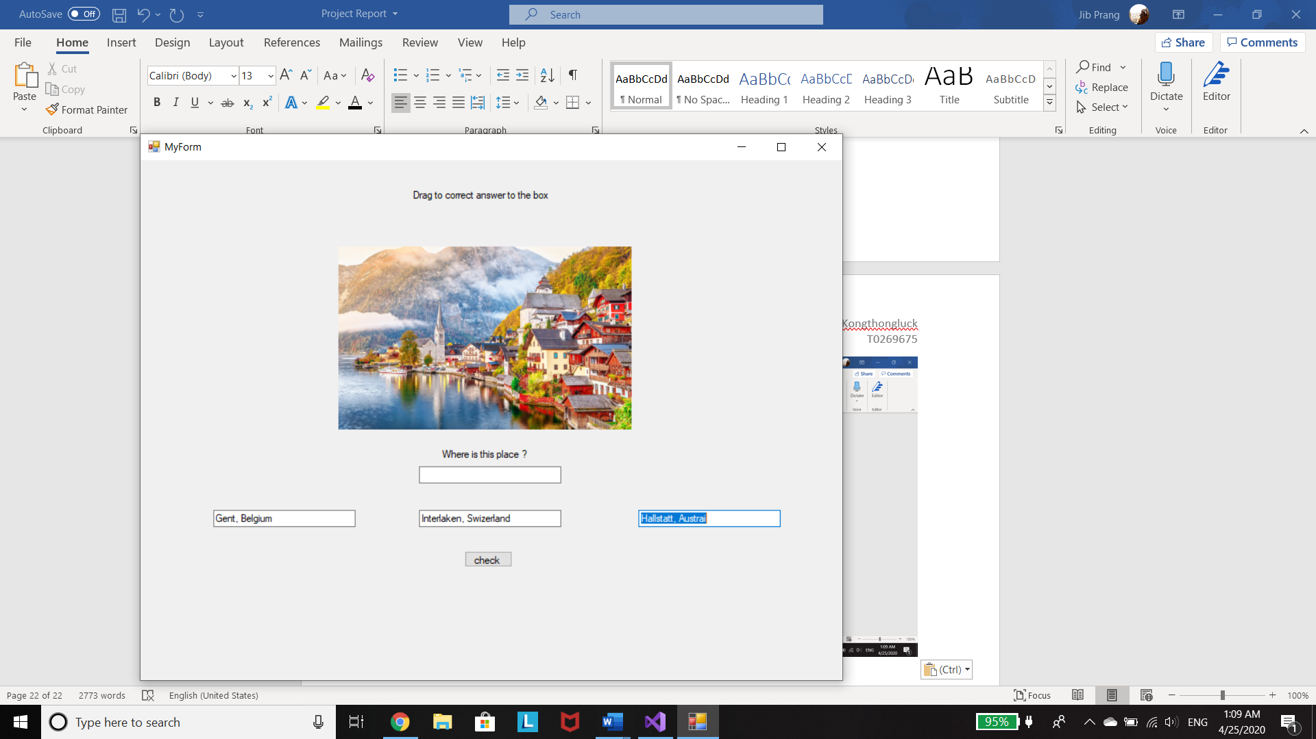

User drag correct answer to the blacnk box and click check to submit the answer. If answer is correct score will add up.

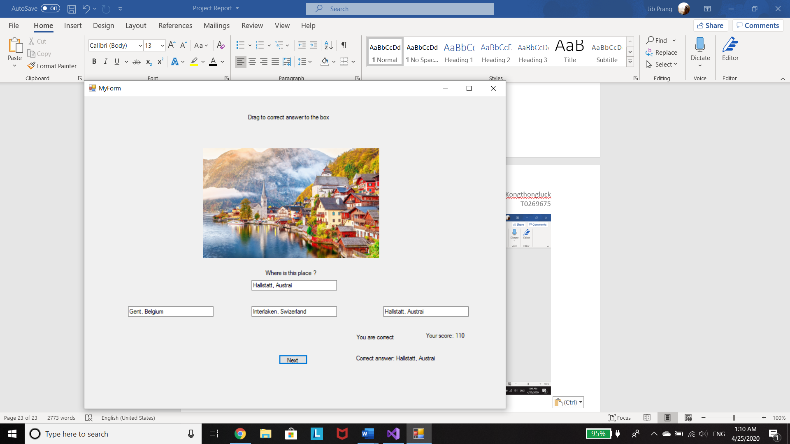

Next question show up when click on next button.

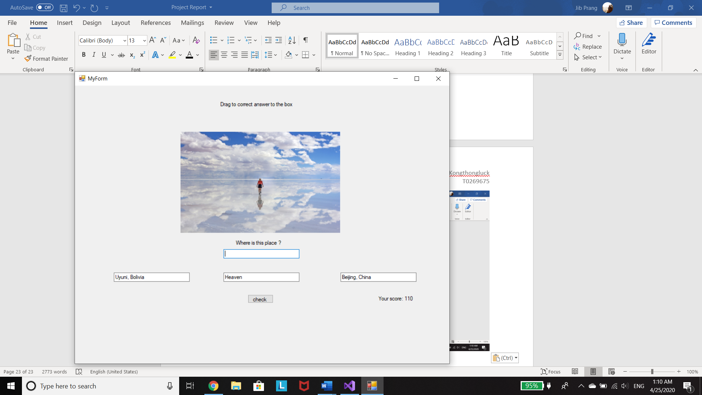

Wrong answer.

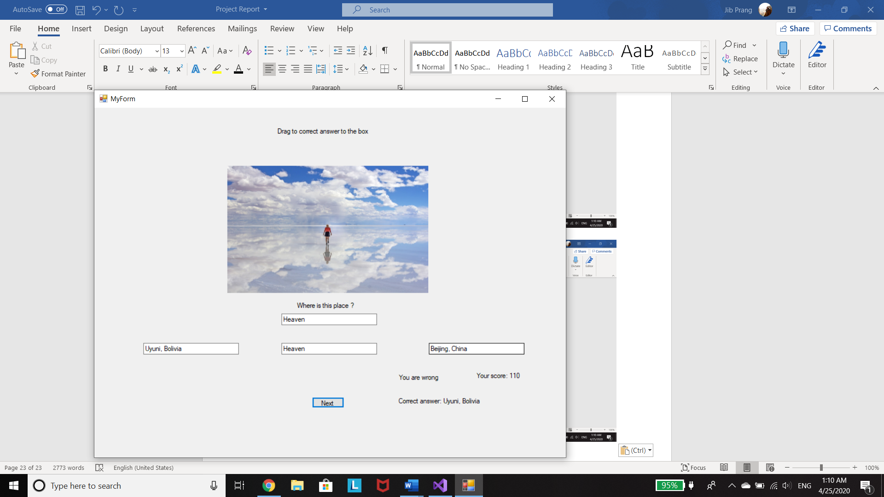

Ending page after user finish the quiz.

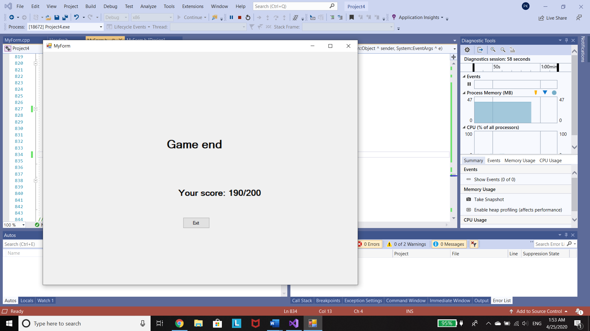

# Source Code

## Header.h

//Purpose of this program is to create a geography quiz game that have user interface.

//The program will display the queation and user will answer question by clicking or drag abd drop the answer.

//Author: Prang Kongthongluck

//Version:4

#pragma once

#include <iostream>

#include <string>

#include <msclr\marshal_cppstd.h>

#include "MyForm.h"

using namespace std;

using namespace System;

int score;

string answer;

int num;

class Question {

protected:// Protected access specifier so inherited class can access to the private attributes

string questionText;

string correctans;

int questionscore;

public:

string Getquestion() { return questionText; }

void Setanswer(string a) { answer = a; }

string Getcorrectans() { return correctans; }

int Getquestionscore() { return questionscore; }

//add up the score

void scorecal(System::Windows::Forms::Label^ label4){

if (answer == correctans) {

score = score + questionscore;

label4->Text = "You are correct";

}

if (answer != correctans) {

label4->Text = "You are wrong";

score = score;

}

}

//convert std::string into system::String^

String^ convert_to_String(std::string x) {

return msclr::interop::marshal_as<String^>(x);

}

String^ Get_question() {

return convert_to_String(questionText);

}

String^ Get_answer() {

return convert_to_String(answer);

}

//label3

String^ Get_correct() {

return convert_to_String(correctans);

}

Question(string, string, int);//constructor

};// Question class end

//declare Question constructer outside the class

//prototyp of constructor

Question::Question(string question, string ca,int qs)

{

questionText = question;

correctans = ca;

questionscore = qs;

}

//class for multi choice question

// MuliQuestion class inherites attributes and methods from Question class

class MultiQuestion : public Question {

private:

string choiceA;

string choiceB;

string choiceC;

string choiceD;

public:

string getChoiceA() { return choiceA; }

void setChoiceA(string A) { choiceA = A; }

string getChoiceB() { return choiceB; }

void setChoiceB(string B) { choiceB = B; }

string getChoiceC() { return choiceC; }

void setChoiceC(string C) { choiceC = C; }

string getChoiceD() { return choiceD; }

void setChoiceD(string D) { choiceD = D; }

//constructer of MultiQuestion class

//MultiQuestion(string A, string B, string C, string D)

MultiQuestion(string, string,int, string, string, string, string);

String^ get_ChoiceA() {

return convert_to_String(choiceA);

}

String^ get_ChoiceB() {

return convert_to_String(choiceB);

}

String^ get_ChoiceC() {

return convert_to_String(choiceC);

}

String^ get_ChoiceD() {

return convert_to_String(choiceD);

}

}; //MultiQuestion end

MultiQuestion::MultiQuestion(string question, string ca,int qs,string A, string B, string C, string D) :

Question(question, ca,qs) {

choiceA = A;

choiceB = B;

choiceC = C;

choiceD = D;

}

MultiQuestion q1("What is the largest city in the world in terms of population?",

"A",

10,

"Beijing",

"New York",

"Mumbai",

"Tokyo");

MultiQuestion q2("Which city is the only city in the world to be located on two separate continents ?",

"C",

10,

"Berlin",

"Cape town",

"Istanbul ",

"Beijing");

MultiQuestion q3("Angel Falls is the world's highest waterfall. In which country is it located? ",

"B",

10,

"Canada",

"Venezuela",

"Brazil ",

"Norway");

MultiQuestion q4("Which European country shares its border with the most neighbours (nine)?",

"D",

10,

"England",

"Hungary",

"Switzerland",

"Germany");

MultiQuestion q5("Which country cover the most tome zones? ",

"A",

10,

"France",

"USA",

"Australia",

"Russia");

MultiQuestion q6("What is the name of the largest lake in UK",

"C",

10,

"Loch Ness",

"Llyn Tegid ",

"Lough Neagh",

"Windermere");

//true/ false question

Question t1("Stonehenge is older than the Pyramids", "True", 10);

Question t2(" New Zealand has more sheep than people", "True", 10);

Question t3("China is once name Siam","False",10);

Question t4("China has more than one time zone", "False", 10);

Question t5("Capital city of thailand has the longest city/place name in the world", "True", 10);

Question t6("The Indian Ocean lies between Africa and Australia", "True", 10);

//drag and drop question

MultiQuestion d1("",

"Hallstatt, Austrai",

20,

"Hallstatt, Austrai",

"Interlaken, Swizerland",

"Gent, Belgium",

"");

MultiQuestion d2("",

"Uyuni, Bolivia",

20,

"Beijing, China",

"Heaven",

"Uyuni, Bolivia",

"");

MultiQuestion d3("",

"Krabi, Thailand",

20,

"Hawaii",

"Krabi, Thailand",

"Maldives",

"");

MultiQuestion d4("",

"Cappadocia, Turkey",

20,

"Cappadocia, Turkey",

"Marrakesh, Morocco",

"Havana, Cuba",

"");

## MyForm.h

#pragma once

#include <msclr\marshal_cppstd.h>

#include "Header.h"

#include "MyForm.h"

namespace Project4 {

using namespace System;

using namespace System::ComponentModel;

using namespace System::Collections;

using namespace System::Windows::Forms;

using namespace System::Data;

using namespace System::Drawing;

/// <summary>

/// Summary for MyForm

/// </summary>

public ref class MyForm : public System::Windows::Forms::Form

{//set fist question to display when program start

int gnum=1 ;

private: System::Windows::Forms::Label^ label1;

private: System::Windows::Forms::Button^ button1;

private: System::Windows::Forms::Label^ label3;

public: System::Windows::Forms::Label^ label4;

private:

private: System::Windows::Forms::Label^ label2;

public:

private: System::Windows::Forms::RadioButton^ radioButton1;

private: System::Windows::Forms::RadioButton^ radioButton2;

private: System::Windows::Forms::RadioButton^ radioButton3;

private: System::Windows::Forms::RadioButton^ radioButton4;

private: System::Windows::Forms::Button^ button2;

private: System::Windows::Forms::Button^ button3;

private: System::Windows::Forms::GroupBox^ groupBox1;

private: System::Windows::Forms::Panel^ panel1;

private: System::Windows::Forms::ComboBox^ comboBox1;

private: System::Windows::Forms::Label^ label5;

private: System::Windows::Forms::Label^ label6;

private: System::Windows::Forms::Button^ button4;

private: System::Windows::Forms::Label^ label7;

private: System::Windows::Forms::Button^ button5;

private: System::ComponentModel::BackgroundWorker^ backgroundWorker1;

private: System::Windows::Forms::PictureBox^ pictureBox1;

private: System::Windows::Forms::Panel^ panel2;

private: System::Windows::Forms::TextBox^ textBox6;

private: System::Windows::Forms::TextBox^ textBox3;

private: System::Windows::Forms::TextBox^ textBox2;

private: System::Windows::Forms::TextBox^ textBox1;

private: System::Windows::Forms::Label^ label9;

private: System::Windows::Forms::Label^ label8;

private: System::Windows::Forms::Label^ label11;

private: System::Windows::Forms::Button^ button6;

private: System::Windows::Forms::Button^ button7;

private: System::Windows::Forms::Button^ button8;

private: System::Windows::Forms::PictureBox^ pictureBox2;

private: System::Windows::Forms::Label^ label12;

private: System::Windows::Forms::PictureBox^ pictureBox3;

private: System::Windows::Forms::PictureBox^ pictureBox4;

private: System::Windows::Forms::Panel^ panel3;

private: System::Windows::Forms::Label^ label14;

private: System::Windows::Forms::Label^ label13;

private: System::Windows::Forms::Panel^ panel4;

private: System::Windows::Forms::Button^ button10;

private: System::Windows::Forms::Button^ button9;

private: System::Windows::Forms::Label^ label15;

private: System::Windows::Forms::PictureBox^ pictureBox5;

private: System::Windows::Forms::Button^ button11;

private: System::Windows::Forms::Label^ label10;

public:

public:

MyForm(void)

{

InitializeComponent();

//

//TODO: Add the constructor code here

//

askequestion(gnum);

String^ gettext = comboBox1->Text->ToString();

String^ dd;

}

protected:

/// <summary>

/// Clean up any resources being used.

/// </summary>

~MyForm()

{

if (components)

{

delete components;

}

}

protected:

protected:

private:

/// <summary>

/// Required designer variable.

/// </summary>

System::ComponentModel::Container^ components;

#pragma region Windows Form Designer generated code

/// <summary>

/// Required method for Designer support - do not modify

/// the contents of this method with the code editor.

/// </summary>

void InitializeComponent(void)

{

System::ComponentModel::ComponentResourceManager^ resources = (gcnew System::ComponentModel::ComponentResourceManager(MyForm::typeid));

this->label1 = (gcnew System::Windows::Forms::Label());

this->button1 = (gcnew System::Windows::Forms::Button());

this->label3 = (gcnew System::Windows::Forms::Label());

this->label4 = (gcnew System::Windows::Forms::Label());

this->label2 = (gcnew System::Windows::Forms::Label());

this->radioButton1 = (gcnew System::Windows::Forms::RadioButton());

this->radioButton2 = (gcnew System::Windows::Forms::RadioButton());

this->radioButton3 = (gcnew System::Windows::Forms::RadioButton());

this->radioButton4 = (gcnew System::Windows::Forms::RadioButton());

this->button2 = (gcnew System::Windows::Forms::Button());

this->button3 = (gcnew System::Windows::Forms::Button());

this->groupBox1 = (gcnew System::Windows::Forms::GroupBox());

this->panel4 = (gcnew System::Windows::Forms::Panel());

this->button10 = (gcnew System::Windows::Forms::Button());

this->button9 = (gcnew System::Windows::Forms::Button());

this->label15 = (gcnew System::Windows::Forms::Label());

this->pictureBox5 = (gcnew System::Windows::Forms::PictureBox());

this->panel1 = (gcnew System::Windows::Forms::Panel());

this->panel2 = (gcnew System::Windows::Forms::Panel());

this->panel3 = (gcnew System::Windows::Forms::Panel());

this->button11 = (gcnew System::Windows::Forms::Button());

this->label14 = (gcnew System::Windows::Forms::Label());

this->label13 = (gcnew System::Windows::Forms::Label());

this->label12 = (gcnew System::Windows::Forms::Label());

this->pictureBox4 = (gcnew System::Windows::Forms::PictureBox());

this->pictureBox3 = (gcnew System::Windows::Forms::PictureBox());

this->pictureBox2 = (gcnew System::Windows::Forms::PictureBox());

this->button8 = (gcnew System::Windows::Forms::Button());

this->button6 = (gcnew System::Windows::Forms::Button());

this->label11 = (gcnew System::Windows::Forms::Label());

this->label10 = (gcnew System::Windows::Forms::Label());

this->label9 = (gcnew System::Windows::Forms::Label());

this->label8 = (gcnew System::Windows::Forms::Label());

this->textBox6 = (gcnew System::Windows::Forms::TextBox());

this->textBox3 = (gcnew System::Windows::Forms::TextBox());

this->textBox2 = (gcnew System::Windows::Forms::TextBox());

this->textBox1 = (gcnew System::Windows::Forms::TextBox());

this->pictureBox1 = (gcnew System::Windows::Forms::PictureBox());

this->button5 = (gcnew System::Windows::Forms::Button());

this->label7 = (gcnew System::Windows::Forms::Label());

this->button4 = (gcnew System::Windows::Forms::Button());

this->label6 = (gcnew System::Windows::Forms::Label());

this->label5 = (gcnew System::Windows::Forms::Label());

this->comboBox1 = (gcnew System::Windows::Forms::ComboBox());

this->button7 = (gcnew System::Windows::Forms::Button());

this->backgroundWorker1 = (gcnew System::ComponentModel::BackgroundWorker());

this->groupBox1->SuspendLayout();

this->panel4->SuspendLayout();

(cli::safe_cast<System::ComponentModel::ISupportInitialize^>(this->pictureBox5))->BeginInit();

this->panel1->SuspendLayout();

this->panel2->SuspendLayout();

this->panel3->SuspendLayout();

(cli::safe_cast<System::ComponentModel::ISupportInitialize^>(this->pictureBox4))->BeginInit();

(cli::safe_cast<System::ComponentModel::ISupportInitialize^>(this->pictureBox3))->BeginInit();

(cli::safe_cast<System::ComponentModel::ISupportInitialize^>(this->pictureBox2))->BeginInit();

(cli::safe_cast<System::ComponentModel::ISupportInitialize^>(this->pictureBox1))->BeginInit();

this->SuspendLayout();

//

// label1

//

this->label1->AutoSize = true;

this->label1->Font = (gcnew System::Drawing::Font(L"Microsoft YaHei", 12, System::Drawing::FontStyle::Regular, System::Drawing::GraphicsUnit::Point,

static_cast<System::Byte>(0)));

this->label1->ImageAlign = System::Drawing::ContentAlignment::TopCenter;

this->label1->Location = System::Drawing::Point(100, 19);

this->label1->Name = L"label1";

this->label1->Size = System::Drawing::Size(69, 27);

this->label1->TabIndex = 0;

this->label1->Text = L"label1";

this->label1->TextAlign = System::Drawing::ContentAlignment::TopRight;

//

// button1

//

this->button1->Location = System::Drawing::Point(445, 244);

this->button1->Name = L"button1";

this->button1->Size = System::Drawing::Size(75, 44);

this->button1->TabIndex = 2;

this->button1->Tag = L"A";

this->button1->Text = L"Check";

this->button1->UseVisualStyleBackColor = true;

this->button1->Click += gcnew System::EventHandler(this, &MyForm::button1_Click);

//

// label3

//

this->label3->AutoSize = true;

this->label3->Location = System::Drawing::Point(276, 322);

this->label3->Name = L"label3";

this->label3->Size = System::Drawing::Size(46, 17);

this->label3->TabIndex = 8;

this->label3->Tag = L"A";

this->label3->Text = L"label3";

//

// label4

//

this->label4->AutoSize = true;

this->label4->ForeColor = System::Drawing::Color::Red;

this->label4->Location = System::Drawing::Point(442, 322);

this->label4->Name = L"label4";

this->label4->Size = System::Drawing::Size(46, 17);

this->label4->TabIndex = 9;

this->label4->Tag = L"A";

this->label4->Text = L"label4";

//

// label2

//

this->label2->AutoSize = true;

this->label2->Location = System::Drawing::Point(640, 322);

this->label2->Name = L"label2";

this->label2->Size = System::Drawing::Size(46, 17);

this->label2->TabIndex = 11;

this->label2->Tag = L"A";

this->label2->Text = L"label2";

//

// radioButton1

//

this->radioButton1->AutoSize = true;

this->radioButton1->Location = System::Drawing::Point(279, 144);

this->radioButton1->Name = L"radioButton1";

this->radioButton1->Size = System::Drawing::Size(110, 21);

this->radioButton1->TabIndex = 13;

this->radioButton1->TabStop = true;

this->radioButton1->Tag = L"A";

this->radioButton1->Text = L"radioButton1";

this->radioButton1->UseVisualStyleBackColor = true;

this->radioButton1->CheckedChanged += gcnew System::EventHandler(this, &MyForm::radioButton1_CheckedChanged_1);

//

// radioButton2

//

this->radioButton2->AutoSize = true;

this->radioButton2->Location = System::Drawing::Point(279, 202);

this->radioButton2->Name = L"radioButton2";

this->radioButton2->Size = System::Drawing::Size(110, 21);

this->radioButton2->TabIndex = 14;

this->radioButton2->TabStop = true;

this->radioButton2->Tag = L"B";

this->radioButton2->Text = L"radioButton2";

this->radioButton2->UseVisualStyleBackColor = true;

this->radioButton2->CheckedChanged += gcnew System::EventHandler(this, &MyForm::radioButton2_CheckedChanged_1);

//

// radioButton3

//

this->radioButton3->AutoSize = true;

this->radioButton3->Location = System::Drawing::Point(594, 144);

this->radioButton3->Name = L"radioButton3";

this->radioButton3->Size = System::Drawing::Size(110, 21);

this->radioButton3->TabIndex = 15;

this->radioButton3->TabStop = true;

this->radioButton3->Tag = L"C";

this->radioButton3->Text = L"radioButton3";

this->radioButton3->UseVisualStyleBackColor = true;

this->radioButton3->CheckedChanged += gcnew System::EventHandler(this, &MyForm::radioButton3_CheckedChanged);

//

// radioButton4

//

this->radioButton4->AutoSize = true;

this->radioButton4->Location = System::Drawing::Point(594, 202);

this->radioButton4->Name = L"radioButton4";

this->radioButton4->Size = System::Drawing::Size(110, 21);

this->radioButton4->TabIndex = 16;

this->radioButton4->TabStop = true;

this->radioButton4->Tag = L"D";

this->radioButton4->Text = L"radioButton4";

this->radioButton4->UseVisualStyleBackColor = true;

this->radioButton4->CheckedChanged += gcnew System::EventHandler(this, &MyForm::radioButton4_CheckedChanged_1);

//

// button2

//

this->button2->Location = System::Drawing::Point(445, 381);

this->button2->Name = L"button2";

this->button2->Size = System::Drawing::Size(75, 23);

this->button2->TabIndex = 17;

this->button2->Tag = L"A";

this->button2->Text = L"Next";

this->button2->UseVisualStyleBackColor = true;

this->button2->Click += gcnew System::EventHandler(this, &MyForm::button2_Click);

//

// button3

//

this->button3->Location = System::Drawing::Point(408, 129);

this->button3->Name = L"button3";

this->button3->Size = System::Drawing::Size(159, 94);

this->button3->TabIndex = 18;

this->button3->Text = L"Continue";

this->button3->UseVisualStyleBackColor = true;

this->button3->Click += gcnew System::EventHandler(this, &MyForm::button3_Click);

//

// groupBox1

//

this->groupBox1->Controls->Add(this->panel4);

this->groupBox1->Controls->Add(this->button3);

this->groupBox1->Controls->Add(this->button2);

this->groupBox1->Controls->Add(this->radioButton4);

this->groupBox1->Controls->Add(this->radioButton3);

this->groupBox1->Controls->Add(this->radioButton2);

this->groupBox1->Controls->Add(this->radioButton1);

this->groupBox1->Controls->Add(this->label2);

this->groupBox1->Controls->Add(this->label4);

this->groupBox1->Controls->Add(this->label3);

this->groupBox1->Controls->Add(this->button1);

this->groupBox1->Controls->Add(this->label1);

this->groupBox1->Location = System::Drawing::Point(12, 12);

this->groupBox1->Name = L"groupBox1";

this->groupBox1->Size = System::Drawing::Size(1068, 724);

this->groupBox1->TabIndex = 19;

this->groupBox1->TabStop = false;

this->groupBox1->Text = L"Multiple choice";

//

// panel4

//

this->panel4->Controls->Add(this->button10);

this->panel4->Controls->Add(this->button9);

this->panel4->Controls->Add(this->label15);

this->panel4->Controls->Add(this->pictureBox5);

this->panel4->Location = System::Drawing::Point(1, 4);

this->panel4->Name = L"panel4";

this->panel4->Size = System::Drawing::Size(1047, 674);

this->panel4->TabIndex = 2;

//

// button10

//

this->button10->Location = System::Drawing::Point(261, 510);

this->button10->Name = L"button10";

this->button10->Size = System::Drawing::Size(127, 56);

this->button10->TabIndex = 3;

this->button10->Text = L"Exit";

this->button10->UseVisualStyleBackColor = true;

this->button10->Click += gcnew System::EventHandler(this, &MyForm::button10_Click);

//

// button9

//

this->button9->Location = System::Drawing::Point(691, 510);

this->button9->Name = L"button9";

this->button9->Size = System::Drawing::Size(127, 56);

this->button9->TabIndex = 2;

this->button9->Text = L"Start";

this->button9->UseVisualStyleBackColor = true;

this->button9->Click += gcnew System::EventHandler(this, &MyForm::button9_Click);

//

// label15

//

this->label15->AutoSize = true;

this->label15->Font = (gcnew System::Drawing::Font(L"Microsoft Sans Serif", 25.8F, System::Drawing::FontStyle::Bold, System::Drawing::GraphicsUnit::Point,

static_cast<System::Byte>(0)));

this->label15->Location = System::Drawing::Point(197, 42);

this->label15->Name = L"label15";

this->label15->Size = System::Drawing::Size(732, 51);

this->label15->TabIndex = 1;

this->label15->Text = L"Welcome to Geography Quiz Game";

//

// pictureBox5

//

this->pictureBox5->Image = (cli::safe_cast<System::Drawing::Image^>(resources->GetObject(L"pictureBox5.Image")));

this->pictureBox5->Location = System::Drawing::Point(361, 140);

this->pictureBox5->Name = L"pictureBox5";

this->pictureBox5->Size = System::Drawing::Size(399, 278);

this->pictureBox5->SizeMode = System::Windows::Forms::PictureBoxSizeMode::StretchImage;

this->pictureBox5->TabIndex = 0;

this->pictureBox5->TabStop = false;

//

// panel1

//

this->panel1->Controls->Add(this->panel2);

this->panel1->Controls->Add(this->button5);

this->panel1->Controls->Add(this->label7);

this->panel1->Controls->Add(this->button4);

this->panel1->Controls->Add(this->label6);

this->panel1->Controls->Add(this->label5);

this->panel1->Controls->Add(this->comboBox1);

this->panel1->Controls->Add(this->button7);

this->panel1->Location = System::Drawing::Point(12, 12);

this->panel1->Name = L"panel1";

this->panel1->Size = System::Drawing::Size(1051, 730);

this->panel1->TabIndex = 19;

this->panel1->Visible = false;

this->panel1->Paint += gcnew System::Windows::Forms::PaintEventHandler(this, &MyForm::panel1_Paint);

//

// panel2

//

this->panel2->Controls->Add(this->panel3);

this->panel2->Controls->Add(this->label12);

this->panel2->Controls->Add(this->pictureBox4);

this->panel2->Controls->Add(this->pictureBox3);

this->panel2->Controls->Add(this->pictureBox2);

this->panel2->Controls->Add(this->button8);

this->panel2->Controls->Add(this->button6);

this->panel2->Controls->Add(this->label11);

this->panel2->Controls->Add(this->label10);

this->panel2->Controls->Add(this->label9);

this->panel2->Controls->Add(this->label8);

this->panel2->Controls->Add(this->textBox6);

this->panel2->Controls->Add(this->textBox3);

this->panel2->Controls->Add(this->textBox2);

this->panel2->Controls->Add(this->textBox1);

this->panel2->Controls->Add(this->pictureBox1);

this->panel2->Location = System::Drawing::Point(0, 0);

this->panel2->Name = L"panel2";

this->panel2->Size = System::Drawing::Size(1051, 681);

this->panel2->TabIndex = 7;

this->panel2->Visible = false;

this->panel2->Paint += gcnew System::Windows::Forms::PaintEventHandler(this, &MyForm::panel2_Paint);

//

// panel3

//

this->panel3->Controls->Add(this->button11);

this->panel3->Controls->Add(this->label14);

this->panel3->Controls->Add(this->label13);

this->panel3->Location = System::Drawing::Point(0, 0);

this->panel3->Name = L"panel3";

this->panel3->Size = System::Drawing::Size(1068, 681);

this->panel3->TabIndex = 27;

this->panel3->Visible = false;

this->panel3->Paint += gcnew System::Windows::Forms::PaintEventHandler(this, &MyForm::panel3_Paint);

//

// button11

//

this->button11->Location = System::Drawing::Point(473, 519);

this->button11->Name = L"button11";

this->button11->Size = System::Drawing::Size(94, 36);

this->button11->TabIndex = 2;

this->button11->Text = L"Exit";

this->button11->UseVisualStyleBackColor = true;

this->button11->Click += gcnew System::EventHandler(this, &MyForm::button11_Click);

//

// label14

//

this->label14->AutoSize = true;

this->label14->Font = (gcnew System::Drawing::Font(L"Microsoft Sans Serif", 16.2F, System::Drawing::FontStyle::Bold, System::Drawing::GraphicsUnit::Point,

static_cast<System::Byte>(0)));

this->label14->Location = System::Drawing::Point(451, 425);

this->label14->Name = L"label14";

this->label14->Size = System::Drawing::Size(116, 32);

this->label14->TabIndex = 1;

this->label14->Text = L"label14";

//

// label13

//

this->label13->AutoSize = true;

this->label13->Font = (gcnew System::Drawing::Font(L"Microsoft Sans Serif", 22.2F, System::Drawing::FontStyle::Bold, System::Drawing::GraphicsUnit::Point,

static_cast<System::Byte>(0)));

this->label13->Location = System::Drawing::Point(409, 262);

this->label13->Name = L"label13";

this->label13->Size = System::Drawing::Size(217, 44);

this->label13->TabIndex = 0;

this->label13->Text = L"Game end ";

//

// label12

//

this->label12->AutoSize = true;

this->label12->Location = System::Drawing::Point(689, 607);

this->label12->Name = L"label12";

this->label12->Size = System::Drawing::Size(54, 17);

this->label12->TabIndex = 25;

this->label12->Text = L"label12";

this->label12->Visible = false;

//

// pictureBox4

//

this->pictureBox4->Image = (cli::safe_cast<System::Drawing::Image^>(resources->GetObject(L"pictureBox4.Image")));

this->pictureBox4->Location = System::Drawing::Point(296, 112);

this->pictureBox4->Name = L"pictureBox4";

this->pictureBox4->Size = System::Drawing::Size(465, 272);

this->pictureBox4->SizeMode = System::Windows::Forms::PictureBoxSizeMode::StretchImage;

this->pictureBox4->TabIndex = 26;

this->pictureBox4->TabStop = false;

this->pictureBox4->Visible = false;

//

// pictureBox3

//

this->pictureBox3->Image = (cli::safe_cast<System::Drawing::Image^>(resources->GetObject(L"pictureBox3.Image")));

this->pictureBox3->Location = System::Drawing::Point(296, 112);

this->pictureBox3->Name = L"pictureBox3";

this->pictureBox3->Size = System::Drawing::Size(465, 272);

this->pictureBox3->SizeMode = System::Windows::Forms::PictureBoxSizeMode::StretchImage;

this->pictureBox3->TabIndex = 25;

this->pictureBox3->TabStop = false;

this->pictureBox3->Visible = false;

//

// pictureBox2

//

this->pictureBox2->Image = (cli::safe_cast<System::Drawing::Image^>(resources->GetObject(L"pictureBox2.Image")));

this->pictureBox2->Location = System::Drawing::Point(296, 112);

this->pictureBox2->Name = L"pictureBox2";

this->pictureBox2->Size = System::Drawing::Size(465, 272);

this->pictureBox2->SizeMode = System::Windows::Forms::PictureBoxSizeMode::StretchImage;

this->pictureBox2->TabIndex = 24;

this->pictureBox2->TabStop = false;

this->pictureBox2->Visible = false;

//

// button8

//

this->button8->Location = System::Drawing::Point(492, 607);

this->button8->Name = L"button8";

this->button8->Size = System::Drawing::Size(93, 42);

this->button8->TabIndex = 23;

this->button8->Text = L"Next";

this->button8->UseVisualStyleBackColor = true;

this->button8->Visible = false;

this->button8->Click += gcnew System::EventHandler(this, &MyForm::button8_Click);

//

// button6

//

this->button6->Location = System::Drawing::Point(492, 532);

this->button6->Name = L"button6";

this->button6->Size = System::Drawing::Size(88, 41);

this->button6->TabIndex = 22;

this->button6->Text = L"check";

this->button6->UseVisualStyleBackColor = true;

this->button6->Click += gcnew System::EventHandler(this, &MyForm::button6_Click);

//

// label11

//

this->label11->AutoSize = true;

this->label11->Location = System::Drawing::Point(689, 556);

this->label11->Name = L"label11";

this->label11->Size = System::Drawing::Size(54, 17);

this->label11->TabIndex = 21;

this->label11->Text = L"label11";

this->label11->Visible = false;

//

// label10

//

this->label10->AutoSize = true;

this->label10->Location = System::Drawing::Point(870, 553);

this->label10->Name = L"label10";

this->label10->Size = System::Drawing::Size(54, 17);

this->label10->TabIndex = 20;

this->label10->Text = L"label10";

this->label10->Visible = false;

//

// label9

//

this->label9->AutoSize = true;

this->label9->Location = System::Drawing::Point(454, 402);

this->label9->Name = L"label9";

this->label9->Size = System::Drawing::Size(144, 17);

this->label9->TabIndex = 19;

this->label9->Text = L"Where is this place \? ";

//

// label8

//

this->label8->AutoSize = true;

this->label8->Location = System::Drawing::Point(408, 29);

this->label8->Name = L"label8";

this->label8->Size = System::Drawing::Size(218, 17);

this->label8->TabIndex = 18;

this->label8->Text = L"Drag to correct answer to the box";

//

// textBox6

//

this->textBox6->AllowDrop = true;

this->textBox6->Location = System::Drawing::Point(421, 428);

this->textBox6->Name = L"textBox6";

this->textBox6->ReadOnly = true;

this->textBox6->Size = System::Drawing::Size(220, 22);

this->textBox6->TabIndex = 13;

this->textBox6->Tag = L"6";

this->textBox6->DragDrop += gcnew System::Windows::Forms::DragEventHandler(this, &MyForm::textBox6_DragDrop);

this->textBox6->DragEnter += gcnew System::Windows::Forms::DragEventHandler(this, &MyForm::textBox6_DragEnter);

//

// textBox3

//

this->textBox3->Location = System::Drawing::Point(102, 491);

this->textBox3->Name = L"textBox3";

this->textBox3->Size = System::Drawing::Size(220, 22);

this->textBox3->TabIndex = 10;

//

// textBox2

//

this->textBox2->Location = System::Drawing::Point(421, 491);

this->textBox2->Name = L"textBox2";

this->textBox2->Size = System::Drawing::Size(220, 22);

this->textBox2->TabIndex = 9;

//

// textBox1

//

this->textBox1->Location = System::Drawing::Point(762, 491);

this->textBox1->Name = L"textBox1";

this->textBox1->Size = System::Drawing::Size(220, 22);

this->textBox1->TabIndex = 8;

this->textBox1->MouseDown += gcnew System::Windows::Forms::MouseEventHandler(this, &MyForm::textBox1_MouseDown);

//

// pictureBox1

//

this->pictureBox1->Image = (cli::safe_cast<System::Drawing::Image^>(resources->GetObject(L"pictureBox1.Image")));

this->pictureBox1->Location = System::Drawing::Point(296, 112);

this->pictureBox1->Name = L"pictureBox1";

this->pictureBox1->Size = System::Drawing::Size(456, 263);

this->pictureBox1->SizeMode = System::Windows::Forms::PictureBoxSizeMode::StretchImage;

this->pictureBox1->TabIndex = 7;

this->pictureBox1->TabStop = false;

//

// button5

//

this->button5->Location = System::Drawing::Point(505, 361);

this->button5->Name = L"button5";

this->button5->Size = System::Drawing::Size(75, 23);

this->button5->TabIndex = 6;

this->button5->Text = L"Next";

this->button5->UseVisualStyleBackColor = true;

this->button5->Visible = false;

this->button5->Click += gcnew System::EventHandler(this, &MyForm::button5_Click);

//

// label7

//

this->label7->AutoSize = true;

this->label7->Location = System::Drawing::Point(679, 306);

this->label7->Name = L"label7";

this->label7->Size = System::Drawing::Size(46, 17);

this->label7->TabIndex = 5;

this->label7->Text = L"label7";

//

// button4

//

this->button4->Location = System::Drawing::Point(505, 255);

this->button4->Name = L"button4";

this->button4->Size = System::Drawing::Size(75, 23);

this->button4->TabIndex = 4;

this->button4->Text = L"Check";

this->button4->UseVisualStyleBackColor = true;

this->button4->Click += gcnew System::EventHandler(this, &MyForm::button4_Click);

//

// label6

//

this->label6->AutoSize = true;

this->label6->ForeColor = System::Drawing::Color::Red;

this->label6->Location = System::Drawing::Point(502, 306);

this->label6->Name = L"label6";

this->label6->Size = System::Drawing::Size(46, 17);

this->label6->TabIndex = 3;

this->label6->Text = L"label6";

this->label6->Visible = false;

//

// label5

//

this->label5->AutoSize = true;

this->label5->Font = (gcnew System::Drawing::Font(L"Microsoft Sans Serif", 12, System::Drawing::FontStyle::Regular, System::Drawing::GraphicsUnit::Point,

static_cast<System::Byte>(0)));

this->label5->Location = System::Drawing::Point(291, 61);

this->label5->Name = L"label5";

this->label5->Size = System::Drawing::Size(64, 25);

this->label5->TabIndex = 2;

this->label5->Text = L"label5";

//

// comboBox1

//

this->comboBox1->Font = (gcnew System::Drawing::Font(L"Microsoft Sans Serif", 10.2F, System::Drawing::FontStyle::Regular, System::Drawing::GraphicsUnit::Point,

static_cast<System::Byte>(0)));

this->comboBox1->FormattingEnabled = true;

this->comboBox1->Items->AddRange(gcnew cli::array< System::Object^ >(2) { L"True", L"False" });

this->comboBox1->Location = System::Drawing::Point(495, 144);

this->comboBox1->Name = L"comboBox1";

this->comboBox1->RightToLeft = System::Windows::Forms::RightToLeft::Yes;

this->comboBox1->Size = System::Drawing::Size(131, 28);

this->comboBox1->TabIndex = 1;

//

// button7

//

this->button7->Location = System::Drawing::Point(457, 244);

this->button7->Name = L"button7";

this->button7->Size = System::Drawing::Size(216, 79);

this->button7->TabIndex = 8;

this->button7->Text = L"Continue";

this->button7->UseVisualStyleBackColor = true;

this->button7->Visible = false;

this->button7->Click += gcnew System::EventHandler(this, &MyForm::button7_Click);

//

// MyForm

//

this->AccessibleName = L"";

this->AutoScaleDimensions = System::Drawing::SizeF(8, 16);

this->AutoScaleMode = System::Windows::Forms::AutoScaleMode::Font;

this->ClientSize = System::Drawing::Size(1092, 748);

this->Controls->Add(this->panel1);

this->Controls->Add(this->groupBox1);

this->Name = L"MyForm";

this->Text = L"MyForm";

this->Load += gcnew System::EventHandler(this, &MyForm::MyForm_Load);

this->groupBox1->ResumeLayout(false);

this->groupBox1->PerformLayout();

this->panel4->ResumeLayout(false);

this->panel4->PerformLayout();

(cli::safe_cast<System::ComponentModel::ISupportInitialize^>(this->pictureBox5))->EndInit();

this->panel1->ResumeLayout(false);

this->panel1->PerformLayout();

this->panel2->ResumeLayout(false);

this->panel2->PerformLayout();

this->panel3->ResumeLayout(false);

this->panel3->PerformLayout();

(cli::safe_cast<System::ComponentModel::ISupportInitialize^>(this->pictureBox4))->EndInit();

(cli::safe_cast<System::ComponentModel::ISupportInitialize^>(this->pictureBox3))->EndInit();

(cli::safe_cast<System::ComponentModel::ISupportInitialize^>(this->pictureBox2))->EndInit();

(cli::safe_cast<System::ComponentModel::ISupportInitialize^>(this->pictureBox1))->EndInit();

this->ResumeLayout(false);

}

#pragma endregion

private: System::Void MyForm_Load(System::Object^ sender, System::EventArgs^ e) {

label2->Visible = false;

label4->Visible = false;

label3->Visible = false;

button1->Visible = true;

button2->Visible = false;

button3->Visible = false;

}

//set answer = A when radioButton 1 is clicked

private: System::Void radioButton1_CheckedChanged_1(System::Object^ sender, System::EventArgs^ e) {

answer = "A";

}

private: System::Void radioButton2_CheckedChanged_1(System::Object^ sender, System::EventArgs^ e) {

answer = "B";

}

private: System::Void radioButton3_CheckedChanged(System::Object^ sender, System::EventArgs^ e) {

answer = "C";

}

private: System::Void radioButton4_CheckedChanged_1(System::Object^ sender, System::EventArgs^ e) {

answer = "D";

}

public: System::Void button1_Click(System::Object^ sender, System::EventArgs^ e) {

//click button 1 to check answer and add score

check(gnum);

label2->Visible = true;

label3->Visible = true;

label4->Visible = true;

button1->Visible = false;

label2->Text = "Your score: " + score.ToString();//convert from int to system string

button2->Visible = true;

button3->Visible = false;

}

private: System::Void button2_Click(System::Object^ sender, System::EventArgs^ e) {

gnum++;//change the question everytime the next button is clecked

askequestion(gnum);

label2->Visible = false;

label4->Visible = false;

label3->Visible = false;

button1->Visible = true;

button2->Visible = false;

//Turn to next page after finish last Muliple choice question

if (gnum > 6) {

button2->Visible = false;

button1->Visible = false;

label1->Text = "end of mutiple choice section";

label3->Visible = false;

label4->Visible = false;

radioButton1->Visible = false;

radioButton2->Visible = false;

radioButton3->Visible = false;

radioButton4->Visible = false;

button3->Visible = true;

;

}

}

private: System::Void button3_Click(System::Object^ sender, System::EventArgs^ e) {

groupBox1->Visible=false;

panel1->Visible = true;

}

//-------------------------------------------T/F question ---------------------------------------------------

private: System::Void panel1_Paint(System::Object^ sender, System::Windows::Forms::PaintEventArgs^ e) {

askequestion(gnum);

//made selected item in combobox = answer

String^ gettext = comboBox1->Text->ToString();

//convert System::String^ to std::string

std::string answerT = msclr::interop::marshal_as< std::string >(gettext);

answer = answerT;

label7->Text = "Your score: " + score.ToString();

label7->Visible = true;

}

private: System::Void button4_Click(System::Object^ sender, System::EventArgs^ e) {

check(gnum);

label7->Text = "Your score: " + score.ToString();

label6->Visible = true;

button5->Visible = true;

button4->Visible = false;

}

private: System::Void button5_Click(System::Object^ sender, System::EventArgs^ e) {

gnum++;

askequestion(gnum);

label6->Visible = false;

button5->Visible = false;

button4->Visible = true;

if (gnum > 12) {

button4->Visible = false;

label7->Visible = false;

label5->Text = "End of true false section";

comboBox1->Visible = false;

label6->Visible = false;

button7->Visible = true;

;

}

}

private: System::Void button7_Click(System::Object^ sender, System::EventArgs^ e) {

//panel1->Visible = false;

panel2->Visible = true;

button7->Visible = false;

}

///////////////////////////drag and drop section///////////////////////////////////////////////////////////

private: System::Void panel2_Paint(System::Object^ sender, System::Windows::Forms::PaintEventArgs^ e) {

askequestion(gnum);

this->textBox2->MouseMove += gcnew System::Windows::Forms::MouseEventHandler(this, &MyForm::textBox1_MouseDown);

this->textBox3->MouseMove += gcnew System::Windows::Forms::MouseEventHandler(this, &MyForm::textBox1_MouseDown);

}

private: System::Void textBox1_MouseDown(System::Object^ sender, System::Windows::Forms::MouseEventArgs^ e) {

TextBox^ tb = (TextBox^)sender;

tb->SelectAll();

//allow text box to move around the form and copy text in textbox1 into the drop downbox

tb->DoDragDrop(tb->Text, DragDropEffects::Copy);

}

private: System::Void textBox6_DragEnter(System::Object^ sender, System::Windows::Forms::DragEventArgs^ e) {

//check dragged value

if (e->Data->GetDataPresent(DataFormats::Text))

{

e->Effect = DragDropEffects::Copy;

}

else

{

e->Effect = DragDropEffects::None;

}

}

private: System::Void textBox6_DragDrop(System::Object^ sender, System::Windows::Forms::DragEventArgs^ e) {

TextBox^ tb = (TextBox^)sender;

//copy text of dragged to textbox

tb->Text = (String^)e->Data->GetData(DataFormats::Text);

//convert System::String^ to std::string

String^ dd = tb->Text->ToString();

std::string answerS = msclr::interop::marshal_as< std::string >(dd);

answer = answerS;

}

private: System::Void button6_Click(System::Object^ sender, System::EventArgs^ e) {

check(gnum);

label10->Text = "Your score: " + score.ToString();

label10->Visible = true;

label11->Visible = true;

button8->Visible = true;

button6->Visible = false;

label12->Visible = true;

}

private: System::Void button8_Click(System::Object^ sender, System::EventArgs^ e) {

gnum++;

askequestion(gnum);

label11->Visible = false;

button6->Visible = true;

button8->Visible = false;

label12->Visible = false;

if (gnum >= 17) {

label11->Visible = false;

button6->Visible = false;

button8->Visible = false;

label12->Visible = false;

label10->Visible = false;

pictureBox4->Visible = false;

textBox1->Visible = false;

textBox2->Visible = false;

textBox3->Visible = false;

textBox6->Visible = false;

panel3->Visible = true;

}

}

//to display the question

private: Void askequestion(int gnum) {

switch (gnum)

{

case 1:

label1->Text = q1.Get_question();

radioButton1->Text = q1.get_ChoiceA();

radioButton2->Text = q1.get_ChoiceB();

radioButton3->Text = q1.get_ChoiceC();

radioButton4->Text = q1.get_ChoiceD();

label3->Text = "Correct answer: " + q1.Get_correct();

break;

case 2:

label1->Text = q2.Get_question();

radioButton1->Text = q2.get_ChoiceA();

radioButton2->Text = q2.get_ChoiceB();

radioButton3->Text = q2.get_ChoiceC();

radioButton4->Text = q2.get_ChoiceD();

label3->Text = "Correct answer: " + q2.Get_correct();

break;

case 3:

label1->Text = q3.Get_question();

radioButton1->Text = q3.get_ChoiceA();

radioButton2->Text = q3.get_ChoiceB();

radioButton3->Text = q3.get_ChoiceC();

radioButton4->Text = q3.get_ChoiceD();

label3->Text = "Correct answer: " + q3.Get_correct();

break;

case 4:

label1->Text = q4.Get_question();

radioButton1->Text = q4.get_ChoiceA();

radioButton2->Text = q4.get_ChoiceB();

radioButton3->Text = q4.get_ChoiceC();

radioButton4->Text = q4.get_ChoiceD();

label3->Text = "Correct answer: " + q4.Get_correct();

break;

case 5:

label1->Text = q5.Get_question();

radioButton1->Text = q5.get_ChoiceA();

radioButton2->Text = q5.get_ChoiceB();

radioButton3->Text = q5.get_ChoiceC();

radioButton4->Text = q5.get_ChoiceD();

label3->Text = "Correct answer: " + q5.Get_correct();

break;

case 6:

label1->Text = q6.Get_question();

radioButton1->Text = q6.get_ChoiceA();

radioButton2->Text = q6.get_ChoiceB();

radioButton3->Text = q6.get_ChoiceC();

radioButton4->Text = q6.get_ChoiceD();

label3->Text = "Correct answer: " + q6.Get_correct();

break;

case 7:

label5->Text = t1.Get_question();

break;

case 8:

label5->Text = t2.Get_question();

break;

case 9:

label5->Text = t3.Get_question();

break;

case 10:

label5->Text = t4.Get_question();

break;

case 11:

label5->Text = t5.Get_question();

break;

case 12:

label5->Text = t6.Get_question();

break;

case 13:

pictureBox1->Visible = true;

textBox1->Text = d1.get_ChoiceA();

textBox2->Text = d1.get_ChoiceB();

textBox3->Text = d1.get_ChoiceC();

label12->Text = "Correct answer: " + d1.Get_correct();

break;

case 14:

pictureBox1->Visible = false;

pictureBox2->Visible = true;

textBox1->Text = d2.get_ChoiceA();

textBox2->Text = d2.get_ChoiceB();

textBox3->Text = d2.get_ChoiceC();

label12->Text = "Correct answer: " + d2.Get_correct();

break;

case 15:

pictureBox2->Visible = false;

pictureBox3->Visible = true;

textBox1->Text = d3.get_ChoiceA();

textBox2->Text = d3.get_ChoiceB();

textBox3->Text = d3.get_ChoiceC();

label12->Text = "Correct answer: " + d3.Get_correct();

break;

case 16:

pictureBox3->Visible = false;

pictureBox4->Visible = true;

textBox1->Text = d4.get_ChoiceA();

textBox2->Text = d4.get_ChoiceB();

textBox3->Text = d4.get_ChoiceC();

label12->Text = "Correct answer: " + d4.Get_correct();

break;

}

}

// for check answer

private: Void check(int gnum) {

switch (gnum) {

case 1:

q1.scorecal(label4);

break;

case 2:

q2.scorecal(label4);

break;

case 3:

q3.scorecal(label4);

break;

case 4:

q4.scorecal(label4);

break;

case 5:

q5.scorecal(label4);

break;

case 6:

q6.scorecal(label4);

break;

case 7:

t1.scorecal(label6);

break;

case 8:

t2.scorecal(label6);

break;

case 9:

t3.scorecal(label6);

break;

case 10:

t4.scorecal(label6);

break;

case 11:

t5.scorecal(label6);

break;

case 12:

t6.scorecal(label6);

break;

case 13:

d1.scorecal(label11);

break;

case 14:

d2.scorecal(label11);

break;

case 15:

d3.scorecal(label11);

break;

case 16:

d4.scorecal(label11);

break;

}

}

//------------------------------------end window--------------------------------------------------------------

private: System::Void panel3_Paint(System::Object^ sender, System::Windows::Forms::PaintEventArgs^ e) {

label14->Text = "Your score: " + score.ToString() + "/200";

}

//-----------------------------------------opening window--------------------------------------------------------

private: System::Void button9_Click(System::Object^ sender, System::EventArgs^ e) {

panel4->Visible = false;

groupBox1->Visible=true;

}

private: System::Void button10_Click(System::Object^ sender, System::EventArgs^ e) {

this->Close();//close the window

}

private: System::Void button11_Click(System::Object^ sender, System::EventArgs^ e) {

this->Close();

}

};

}

# Reference

Balaji S, 2017. *C# Drag And Drop On Picturebox*. [video] Available at: <https://www.youtube.com/watch?v=aHs6lrInrsY&list=PLzTb6bDynO5mLyAnmXTNkm6iW9NH332be&index=6> [Accessed 21 April 2020].

Fun Quizzes, 2020. *80 Geography Quiz Questions And Their Answers - Fun Quizzes*. [online] Free Online Fun Quizzes and General Knowledge Quiz Questions and Answers. Available at: <https://www.funquizzes.uk/geography-quiz-questions/> [Accessed 21 April 2020].

Gen Grievous, 2017. *Visual Studio 2017 - Windows Forms - Combobox - Insert Items And Read Selected*. [video] Available at: <https://www.youtube.com/watch?v=peHxdNuIjHM&list=PLzTb6bDynO5mLyAnmXTNkm6iW9NH332be&index=3> [Accessed 21 April 2020].

iTzAdam5X, 2011. *C# Tutorial 30, Drag And Drop*. [video] Available at: <https://www.youtube.com/watch?v=d0J3VKBA4Xs&list=PLzTb6bDynO5mLyAnmXTNkm6iW9NH332be&index=5> [Accessed 24 April 2020].

Jones, R., 2017. *Visual Studio 2015 - Show Hide Windows Forms*. [image] Available at: <https://www.youtube.com/watch?v=j0uRPDxG37g&list=PLzTb6bDynO5mLyAnmXTNkm6iW9NH332be&index=3&t=1s> [Accessed 24 April 2020].

Levesque, T., 2013. *Getting Value Of Selected Item In List Box As String*. [online] Stack Overflow. Available at: <https://stackoverflow.com/questions/15003095/getting-value-of-selected-item-in-list-box-as-string> [Accessed 21 April 2020].

Moo ICT, 2020. *How To Make A Simple Multiple Choice Quiz Game In Windows Form And C#*. [video] Available at: <https://www.youtube.com/watch?v=hQDjz2ISklw&list=PLzTb6bDynO5mLyAnmXTNkm6iW9NH332be&index=2> [Accessed 24 April 2020].

Pubquizquestionshq.com. 2015. *Places Quiz (Round 1) | Pub Quiz Questions HQ*. [online] Available at: <https://pubquizquestionshq.com/quiz/places-quiz-round-1> [Accessed 24 April 2020].

Shai, 2012. *Change Label Text From Different Header File, Visual C++ 2010?*. [online] Stack Overflow. Available at: <https://stackoverflow.com/questions/20980056/change-label-text-from-different-header-file-visual-c-2010> [Accessed 21 April 2020].

Skyflok.com. 2018. *10 Interesting Facts About The United Kingdom You Will Want To Know -*. [online] Available at: <https://www.skyflok.com/2018/09/27/30-interesting-uk-facts/> [Accessed 21 April 2020].

sumitparakh, 2013. *Drag And Drop Effect In Textbox And Listbox*. [video] Available at: <https://www.youtube.com/watch?v=B8KbUkNvtHE&list=PLzTb6bDynO5mLyAnmXTNkm6iW9NH332be&index=7> [Accessed 21 April 2020].

THEDΛRKJOKER, 2010. *C# Tutorial: Multiple Pages On The Form [Using Panels]*. [video] Available at: <https://www.youtube.com/watch?v=CDOXzz_0gYE&list=PLzTb6bDynO5mLyAnmXTNkm6iW9NH332be&index=4> [Accessed 24 April 2020].

winforms, 2015. *Drag And Drop Operation In Windows Form C#*. [video] Available at: <https://www.youtube.com/watch?v=4BYK7HhxPPk&list=PLzTb6bDynO5mLyAnmXTNkm6iW9NH332be&index=8> [Accessed 21 April 2020].

## Image

AGENCY, A., 2019. *Balloon Festival*. [image] Available at: <https://www.dailysabah.com/turkey/2019/07/02/cappadocia-awaits-tourists-for-magical-hot-air-balloon-fest>

Feel Good Studio, 2019. *Hallstatt*. [image] Available at: <https://www.travelawaits.com/2482751/reasons-to-visit-hallstatt-austria/>

kittyshow, n.d. *World Map*. [image] Available at: <https://www.vectorstock.com/royalty-free-vector/world-map-countries-geography-vector-9920386>

Kumar, C., 2017. *SALAR DE UYUNI, BOLIVIA*. [image] Available at: <https://www.suitcaseandi.com/the-largest-mirror-on-earth-salar-de-uyuni-bolivia/>

makewebeasy.com, n.d. *Phi Phi Island*. [image] Available at: <https://www.andamanluxuryyacht.com/phiphiislandtour>